Animation 1 -current read up to section 14- 2:38 mins
 | VO | Visual
 | Have you ever felt happy, sad, angry or worried? How about jealous, embarrassed or scared? And shy, lonely or just not good enough? | WIDE SHOT (WS) with slow zoom in to section 2- Main character (MC) is alone on generic background. As each emotion is said they look happy, sad, angry, worried etc… in an exaggerated way and emoticon-like characters pop up around him.  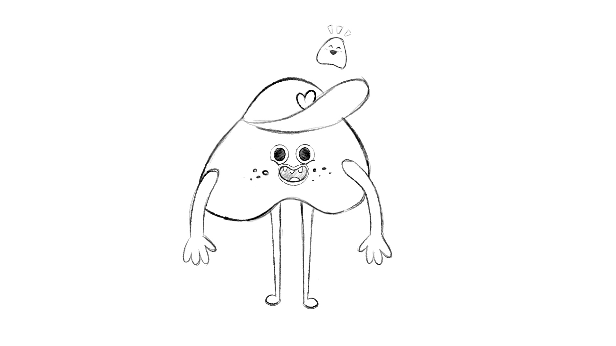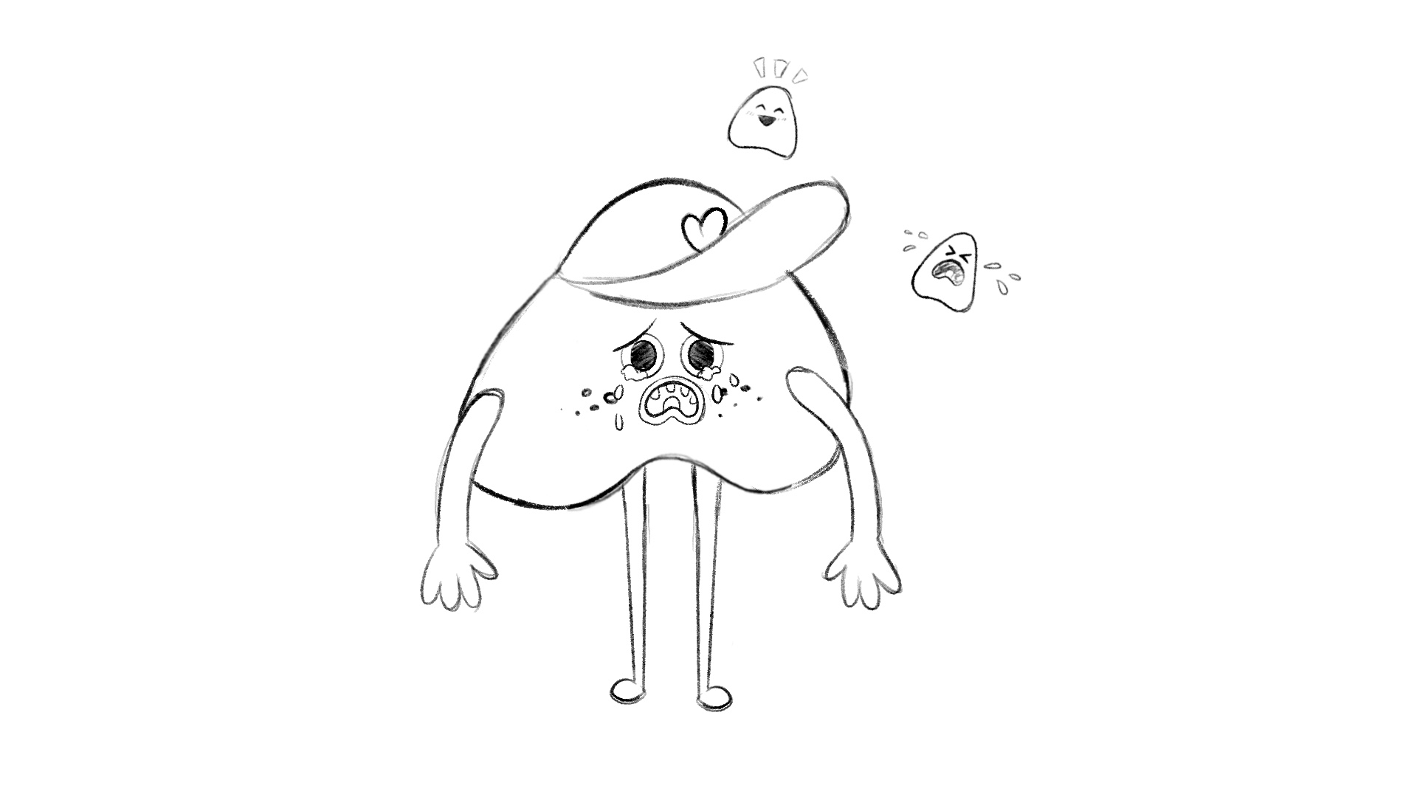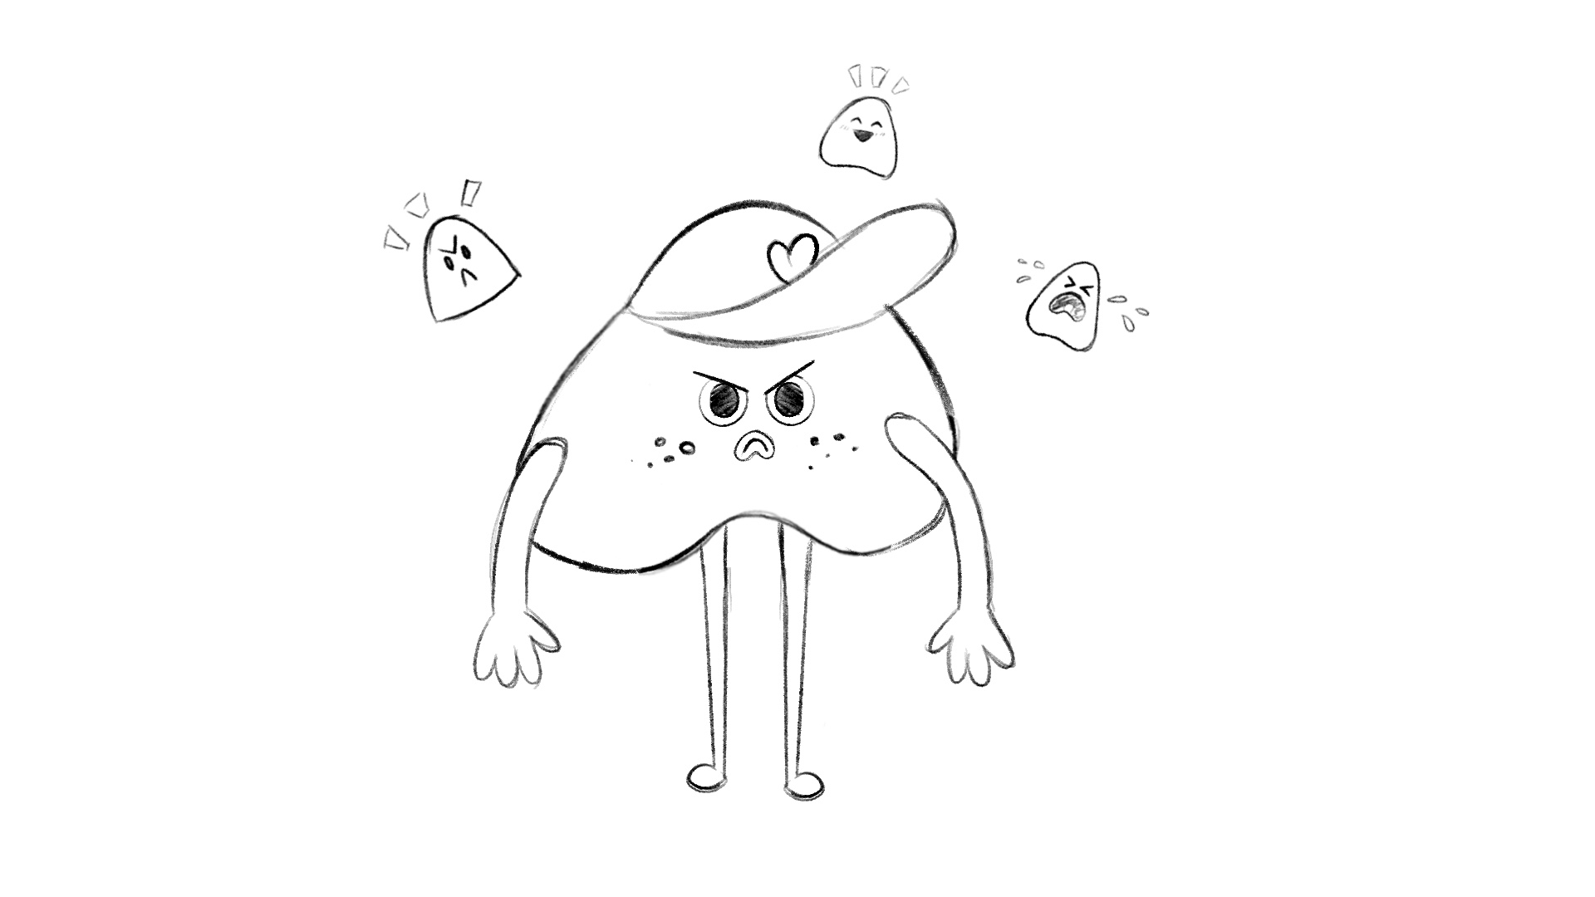
 | We all feel these feelings from time to time. | 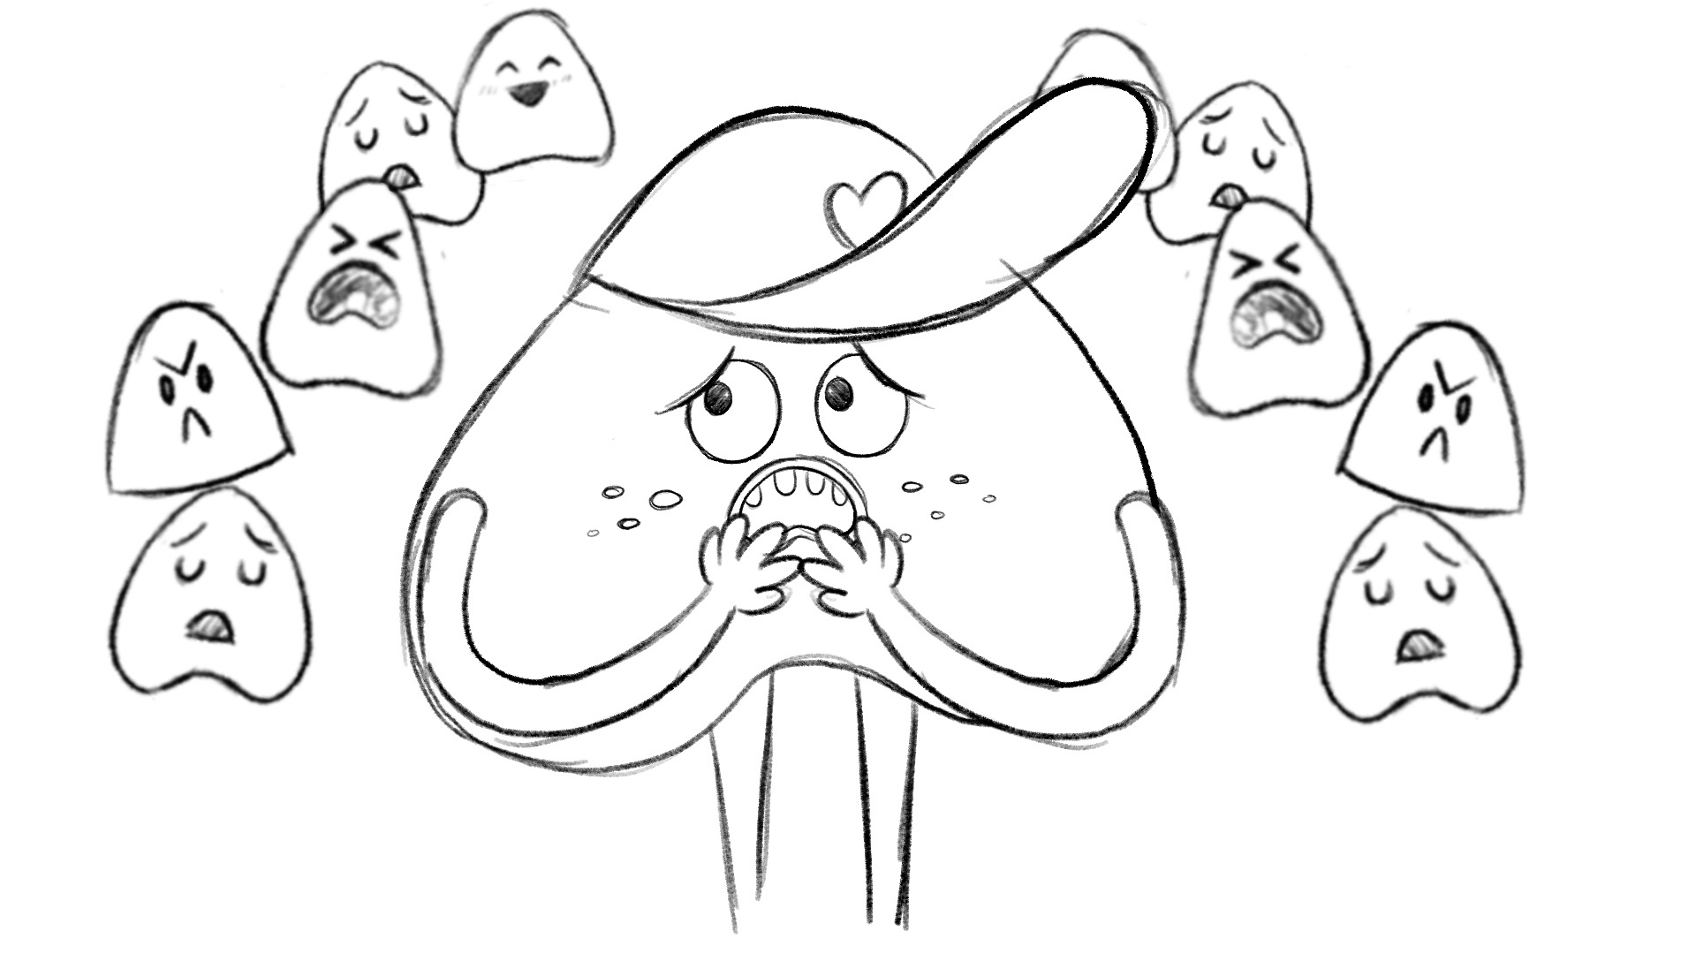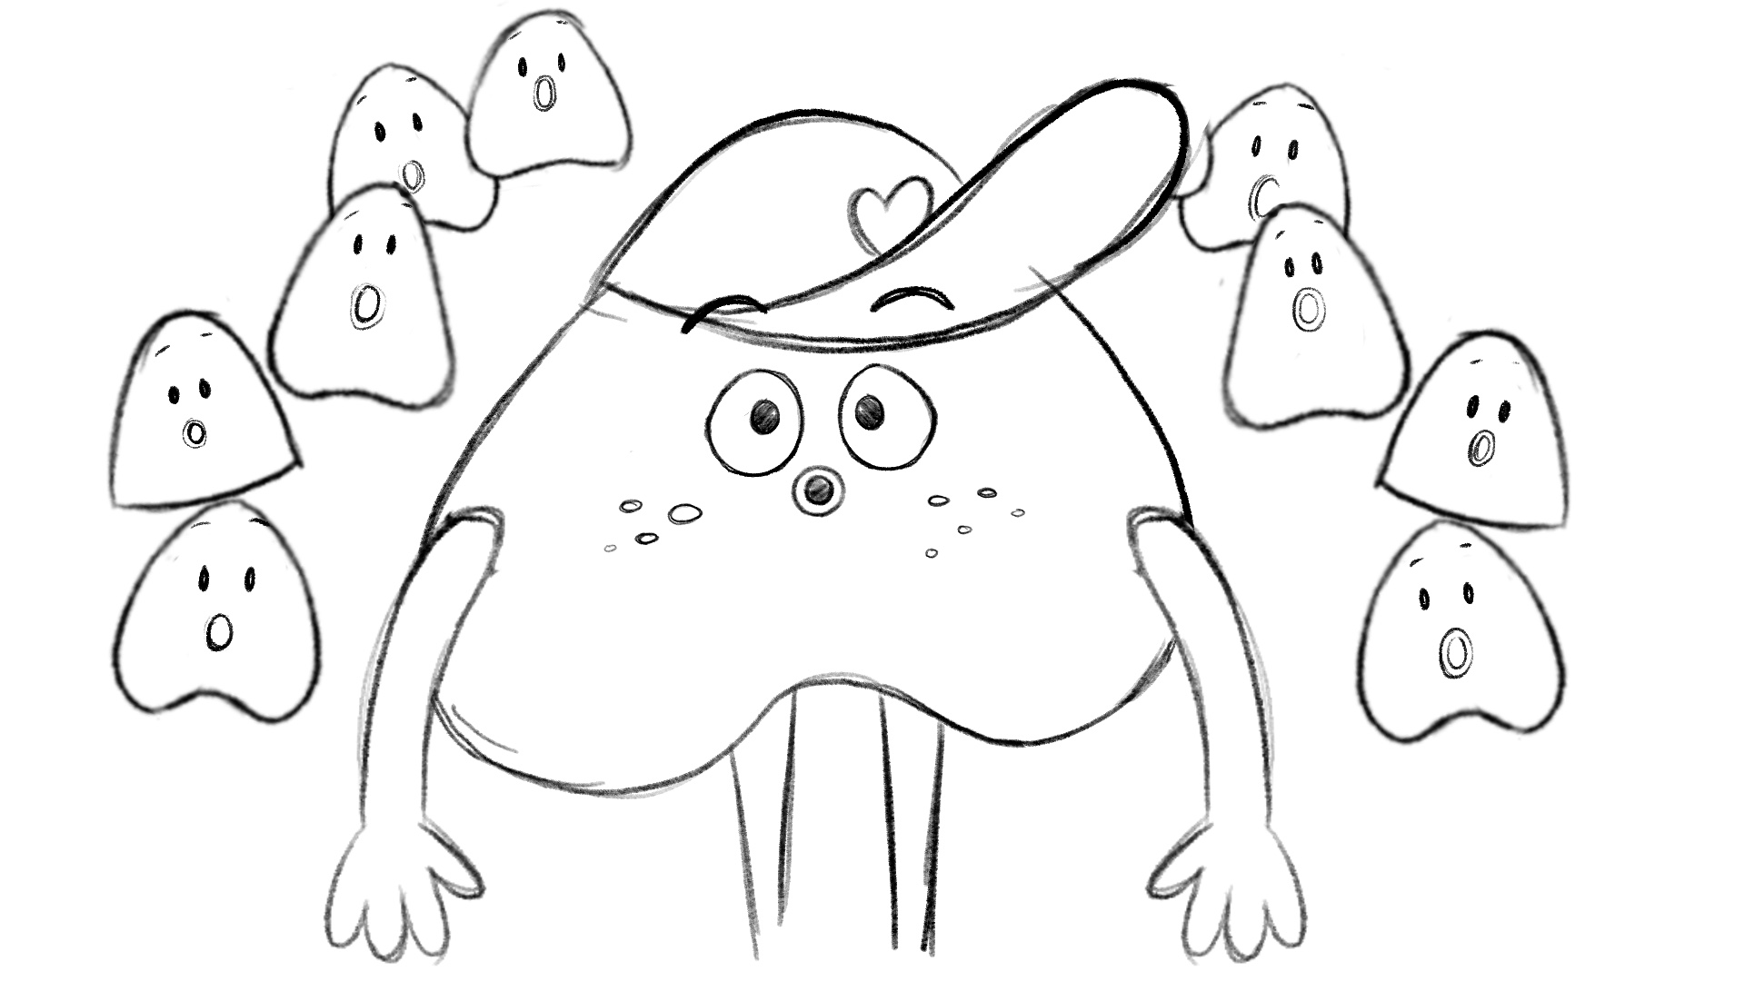  MC looks at the camera shocked, a whole lot more emoticons pop out and they look confused.
 | Everybody feels feelings all day long, and they often change from one moment to the next. | All the other iHeart Club characters (cubs) walk on screen with their own sets of emojis popping up and disappearing.  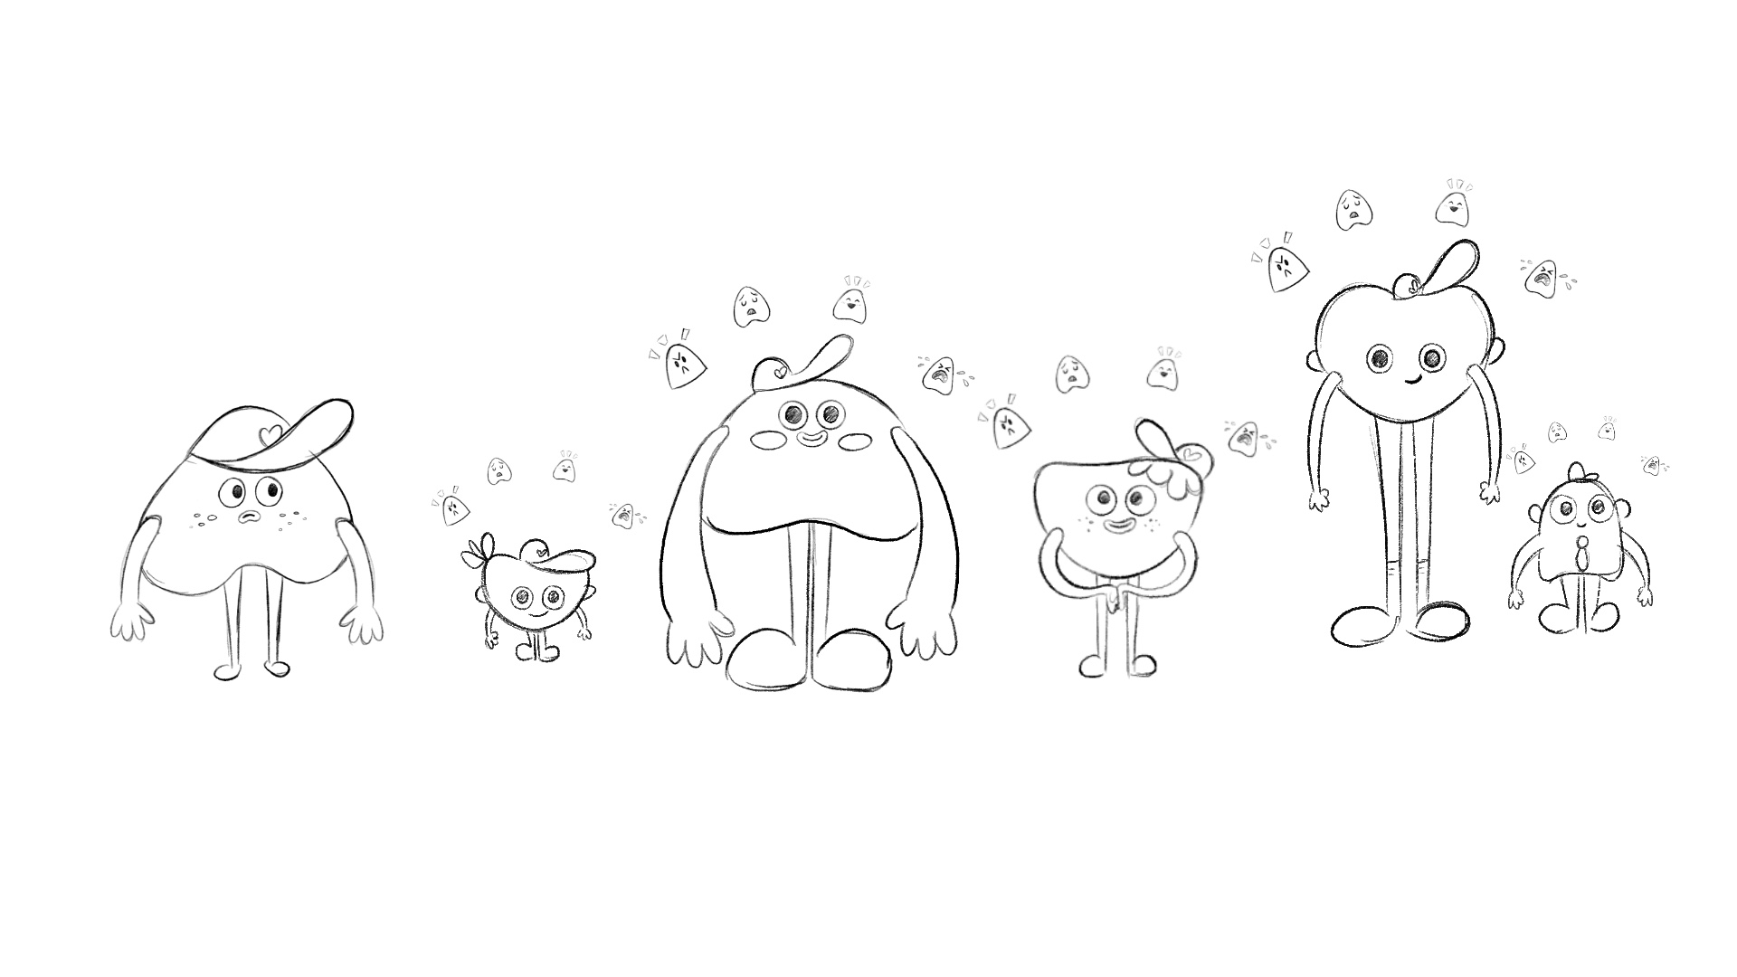
 | Can you count the different feelings you’ve already felt today? A lot, I bet! Feelings play a big role in our lives. They colour our world. They affect the way we act and behave. | Zoom to MID CLOSE UP (MCU)- MC is thinkinging and counting on their fingers; sluggish, anxious, happy, bored, excited, frustrated. A thought cloud pops up with each emotion written in it that is big enough to show the background reflects each of the moods  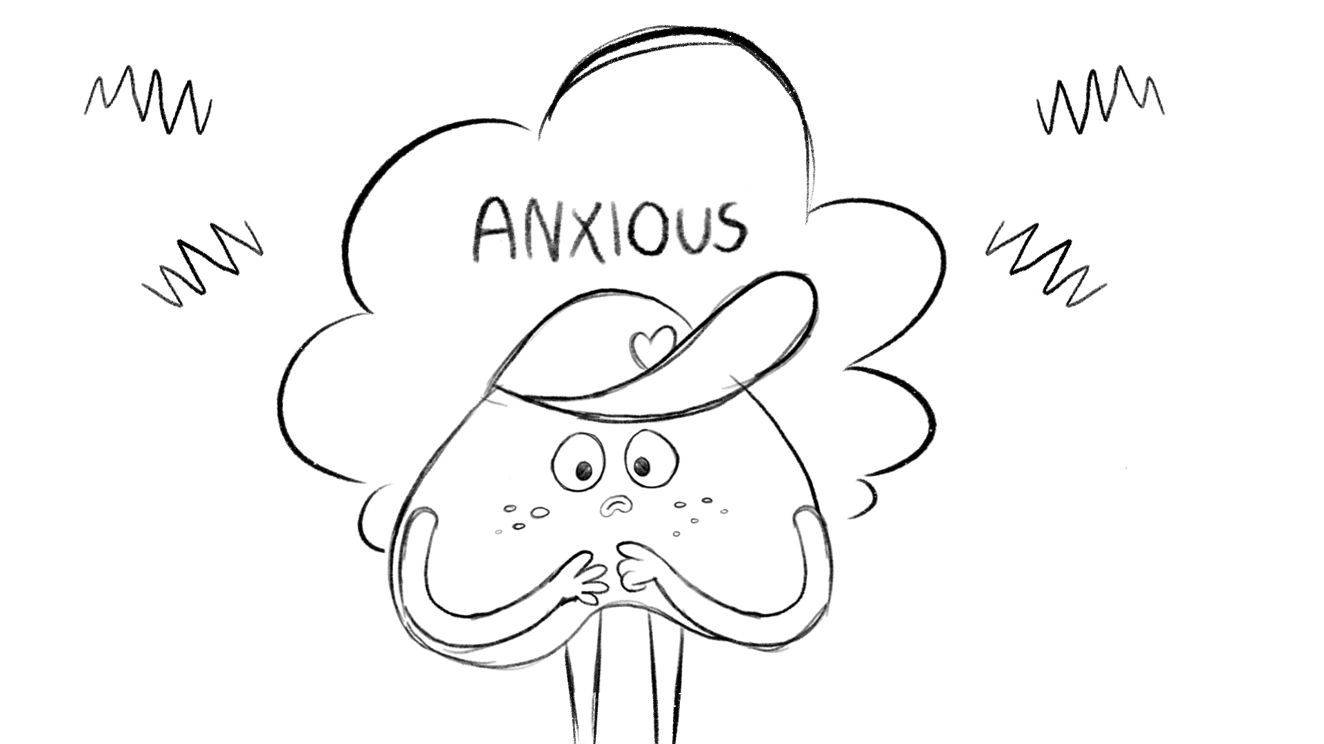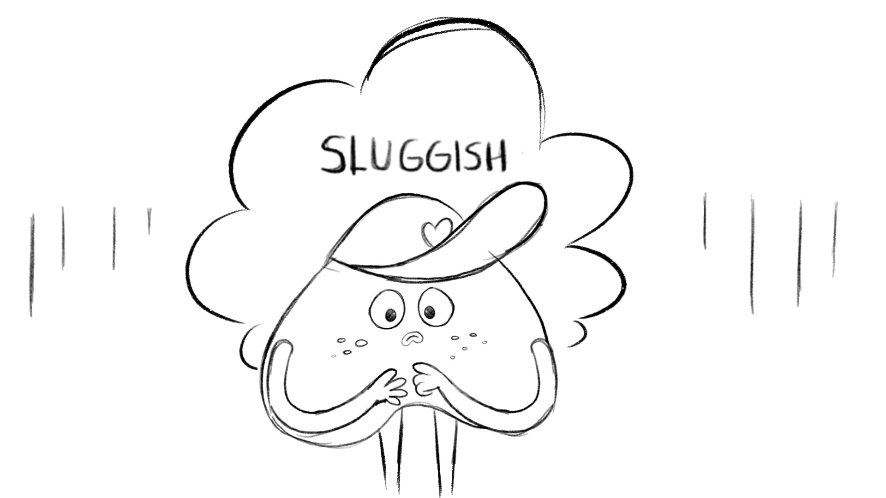
 | So, where do our feelings come from? It’s really important to know! | Question mark pops up and they wonder. We zoom into the iHeart emblem on his hat to fill the screen with flat colour.  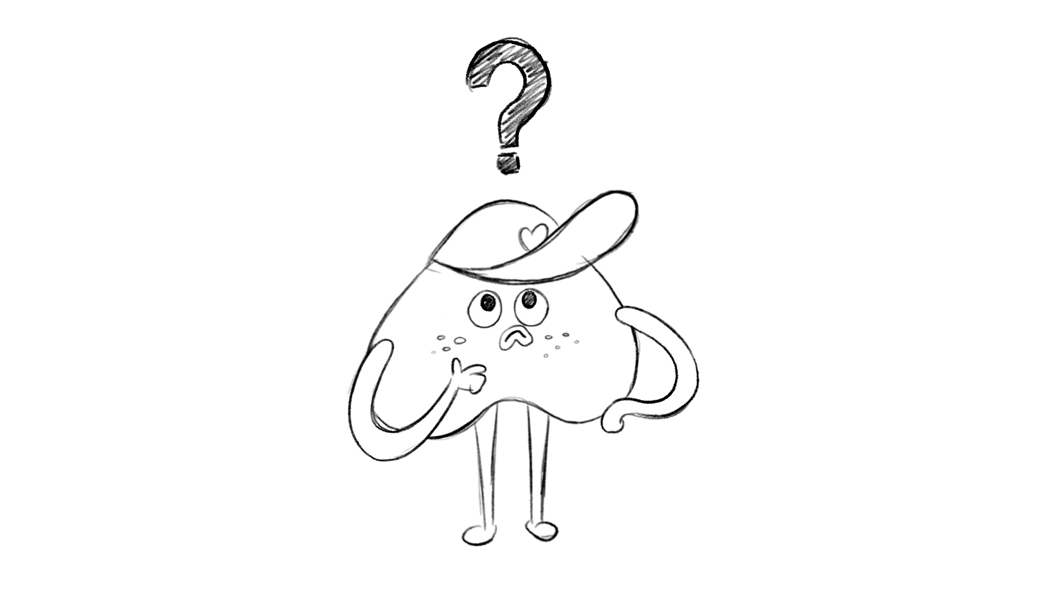
 | Well, many people believe that feelings come from things like exams, the weather and friends or things that happen to us like exam results and how people treat us . | Zoom to MID SHOT- Two cubs sit at school desk writing and we can see it is raining outside. Anxious emoji are popping out of the exam paper into Secondary Character 1 (SC1), sad emojis stream in from the window towards SC1, the friends look at eachother and amused emojis stream towards SC1.  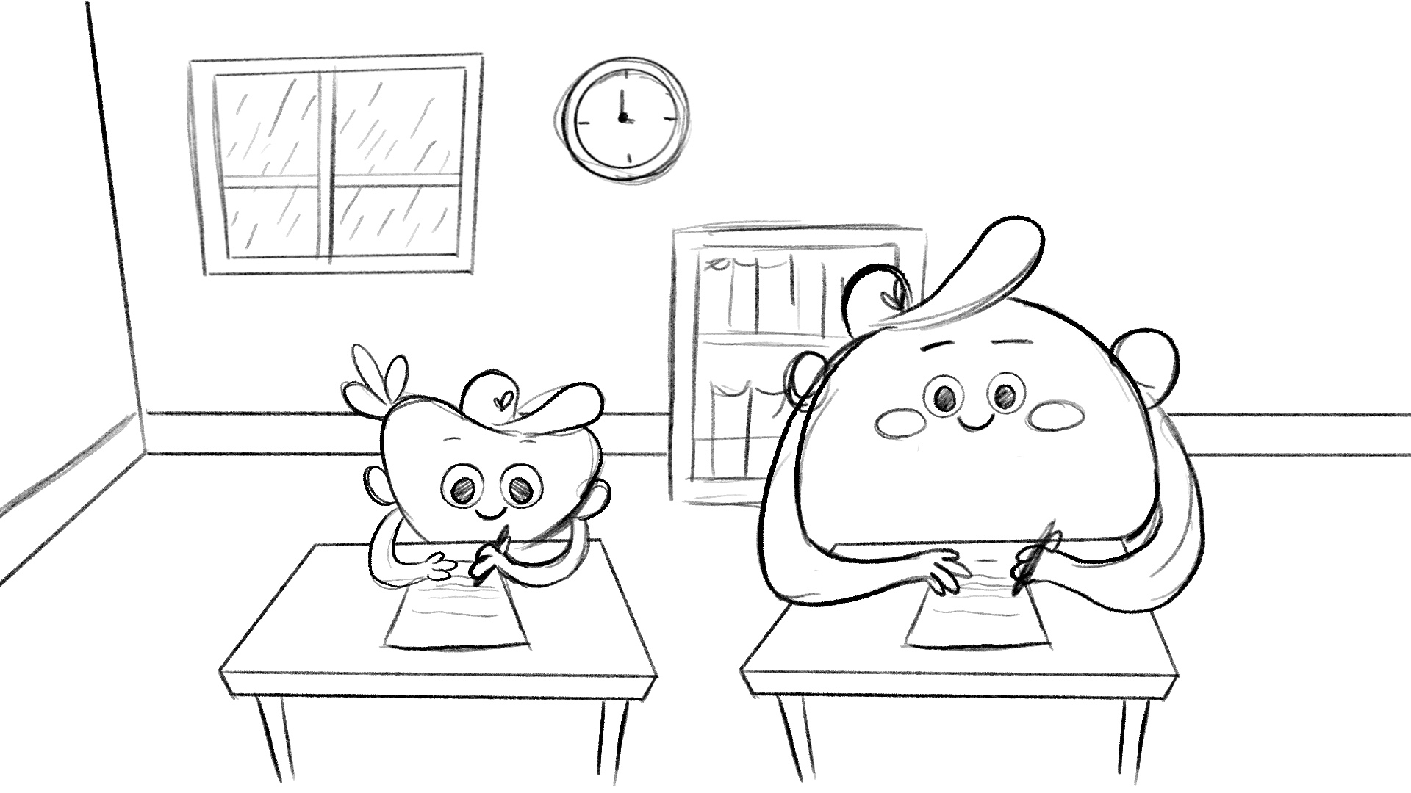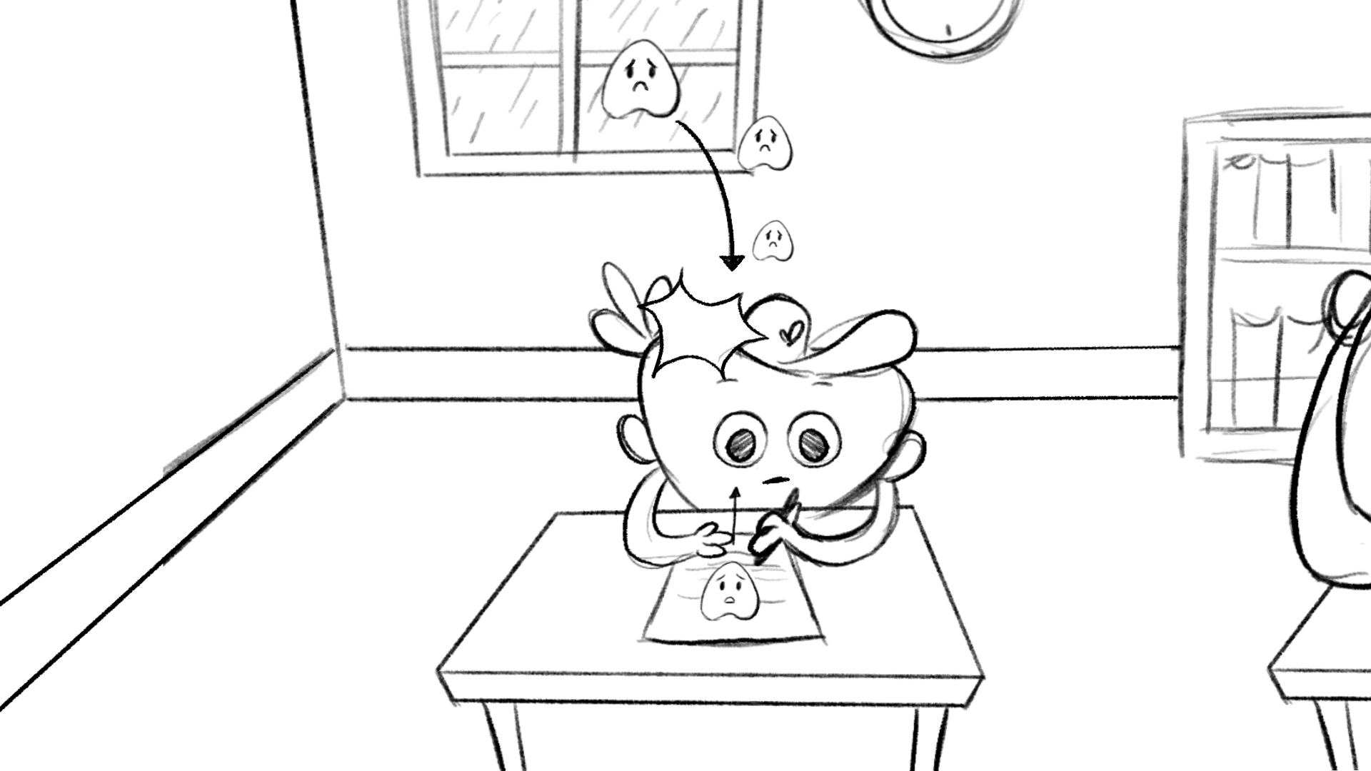  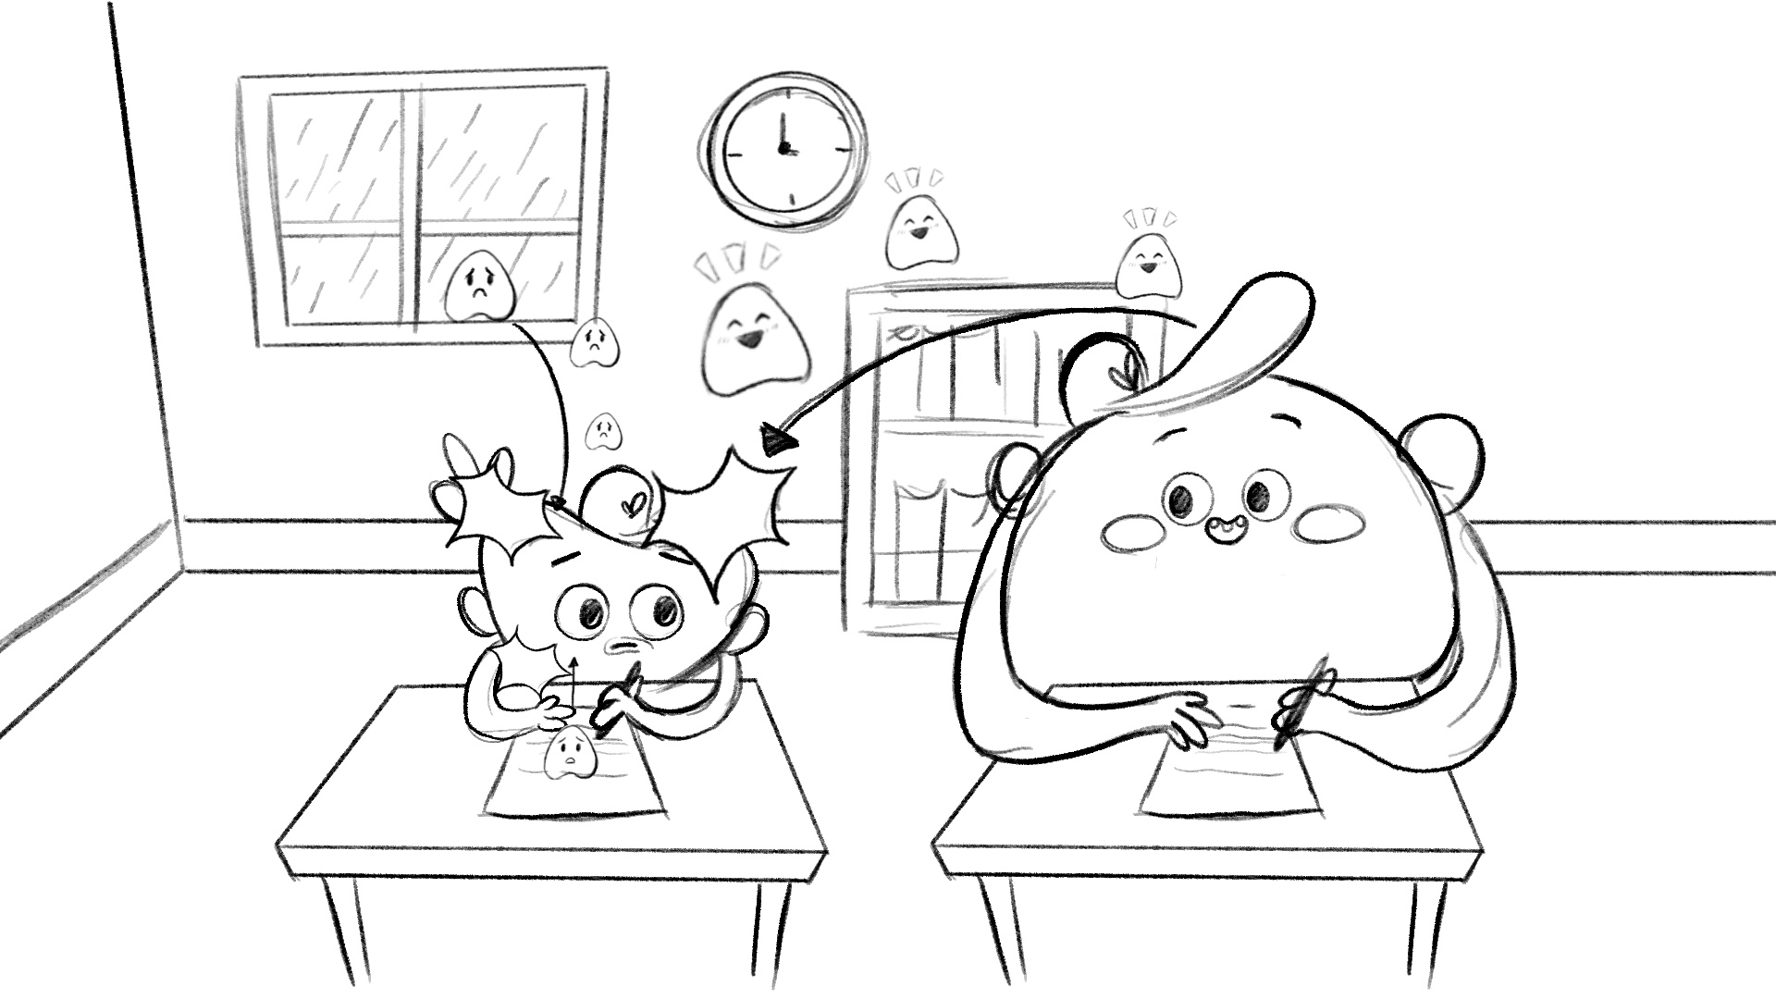
 | But have you ever noticed that two people can be in the exact same situation and yet have completely different feelings? | SC1 and SC2 look at camera like “oh?”  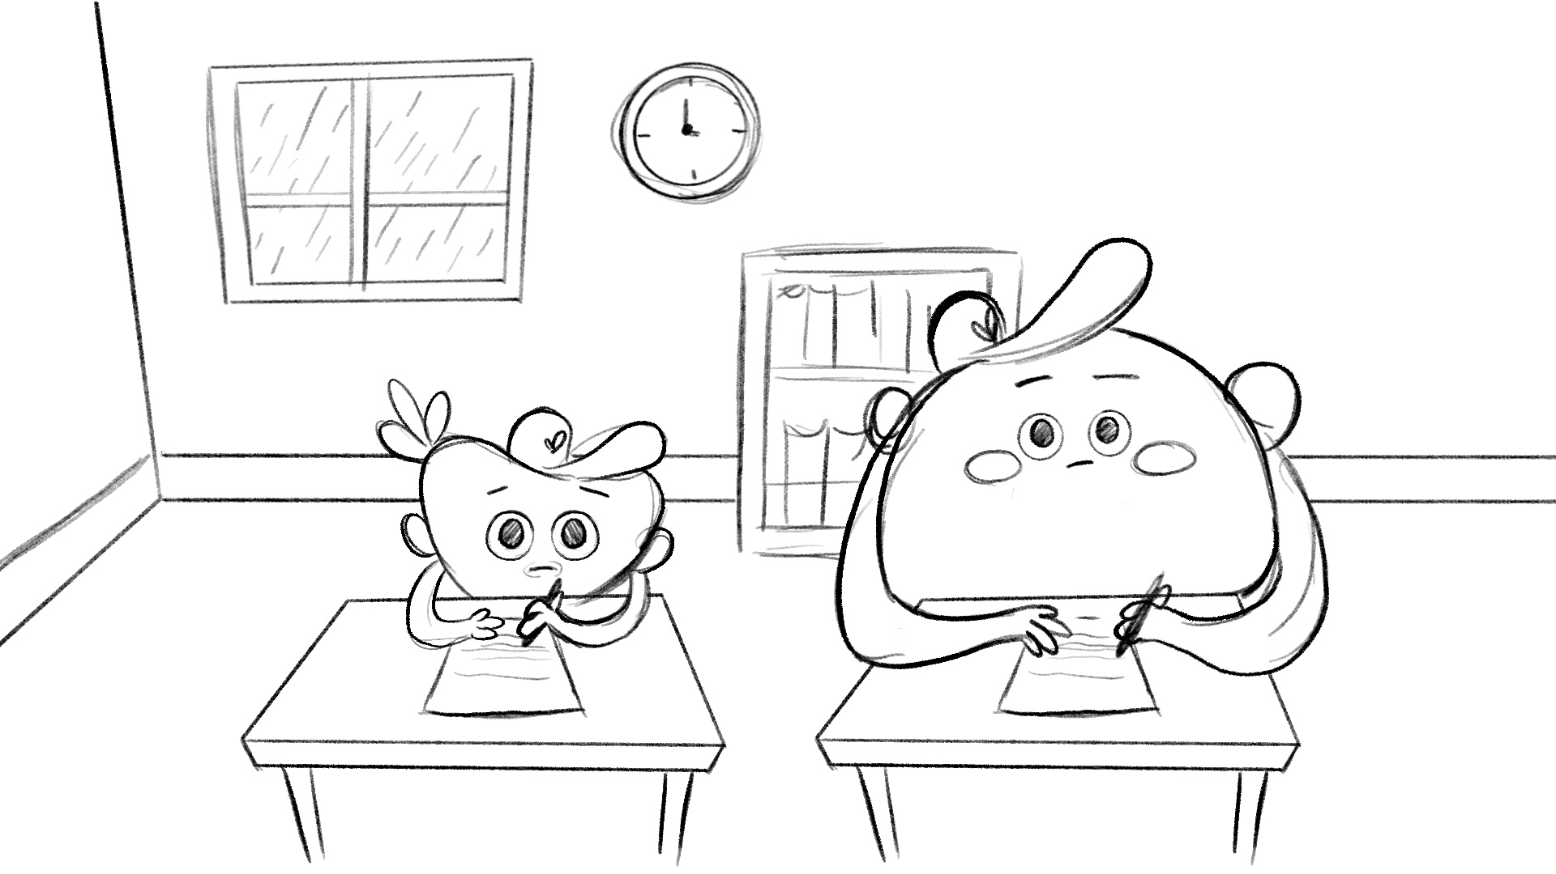
 | For example, imagine you’re visiting a family that has a cat. You might think “Oh no, I hate cats’ and feel uncomfortable. Your sister might think ‘ Ah, that’s brilliant!I love cats’ and feel excited.  How is this possible? | Scene quickly pans off to reveal two new iHeart club members appear (SC3 and SC4) (WIDE SHOT). Cat pops into existence and rubs it’s head on SC3, uncomfortable emojis come from the cat and explode on SC3 popping in a jagged way then thought “i HATE cats” appears in thought cloud.  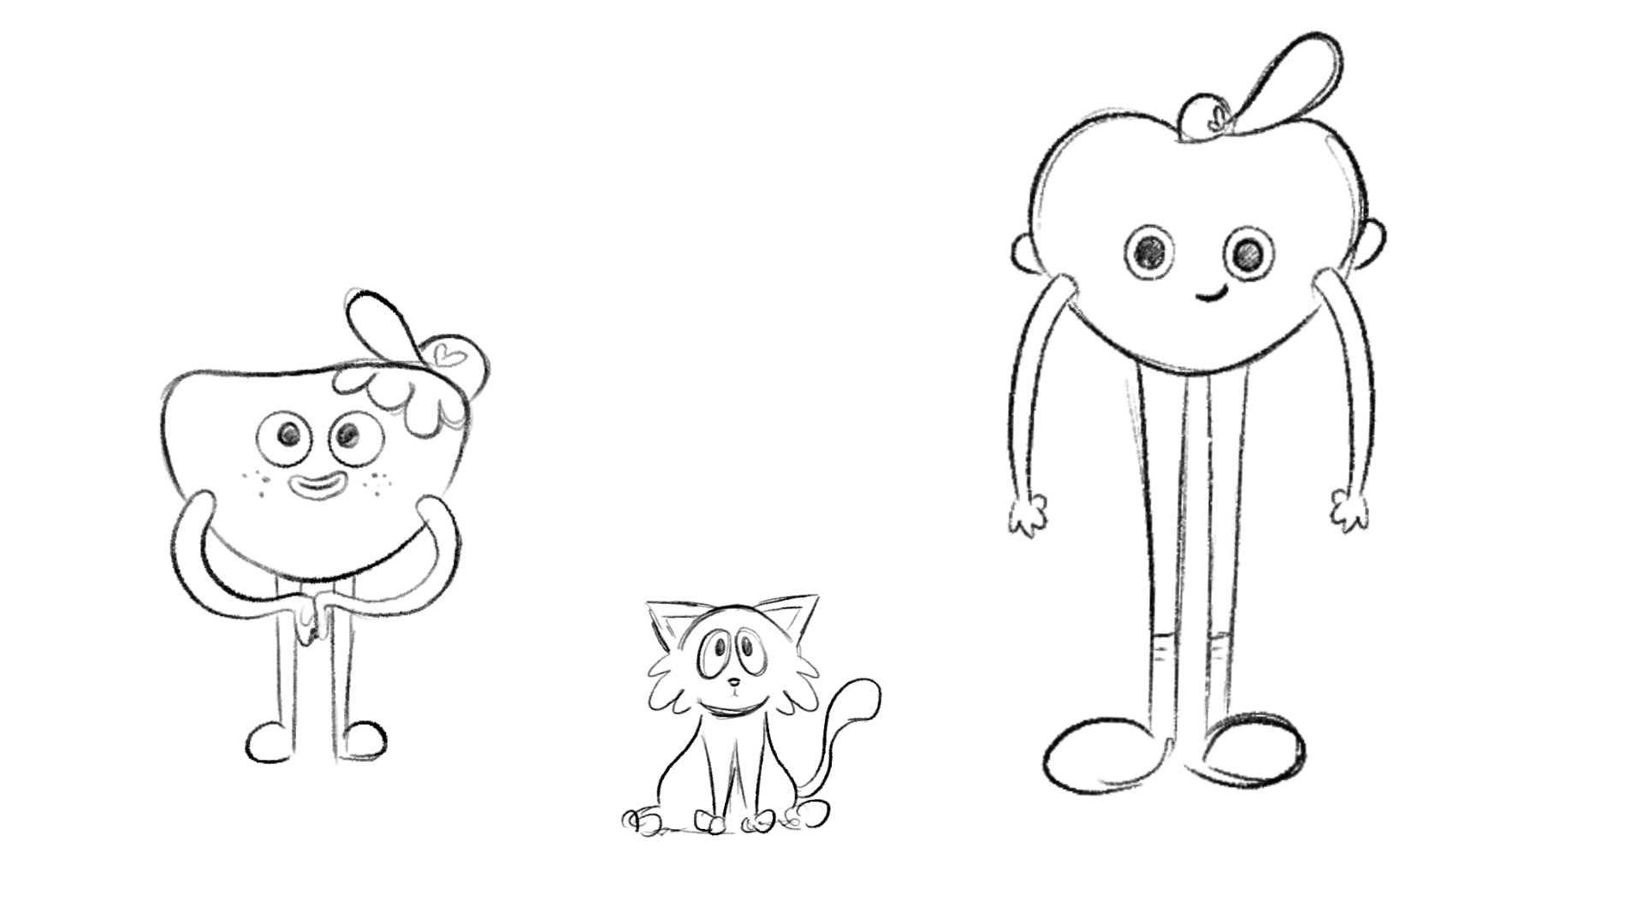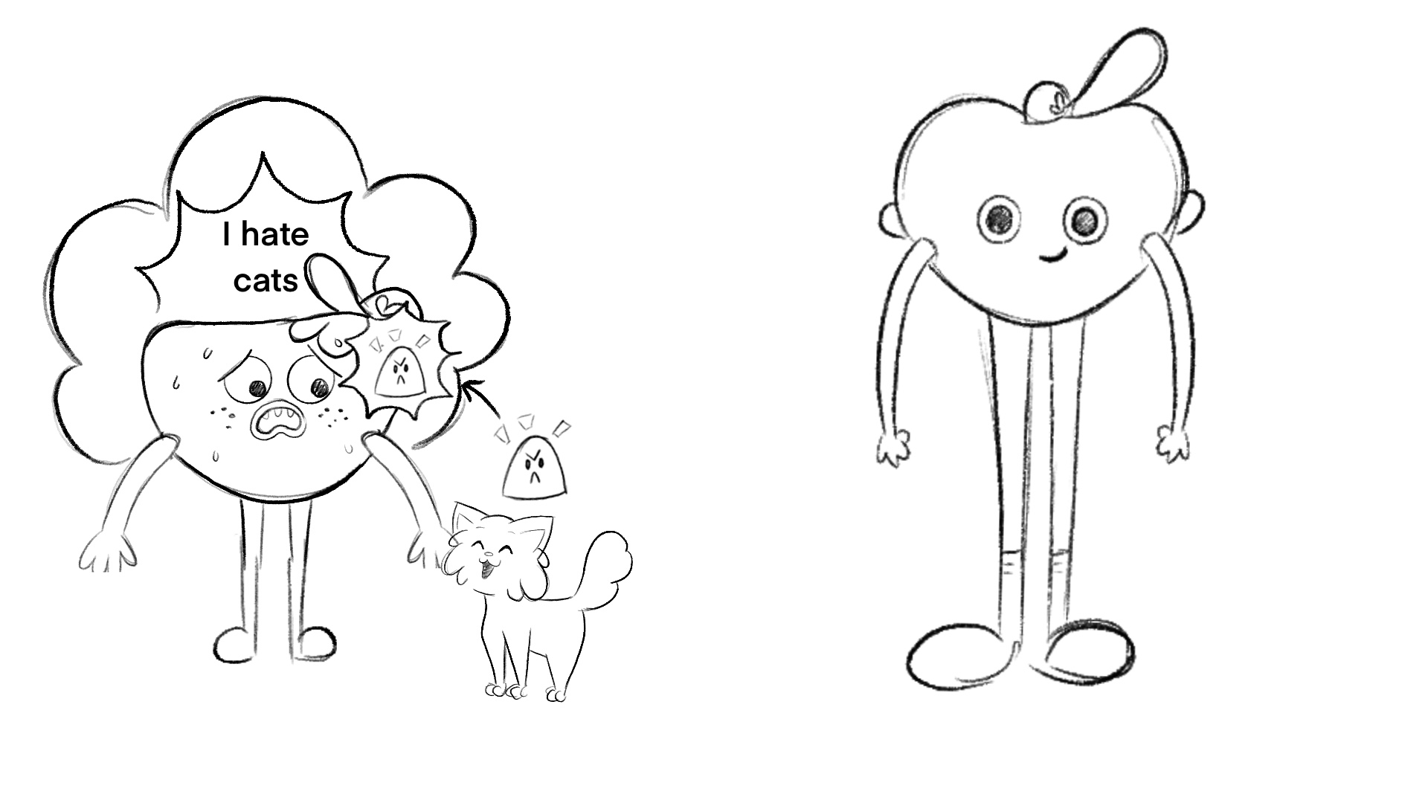  Cat walks up to SC4 who pets the cat, excited emojis come from the cat and pop in a happy way then their thought cloud reads “I LOVE cats”  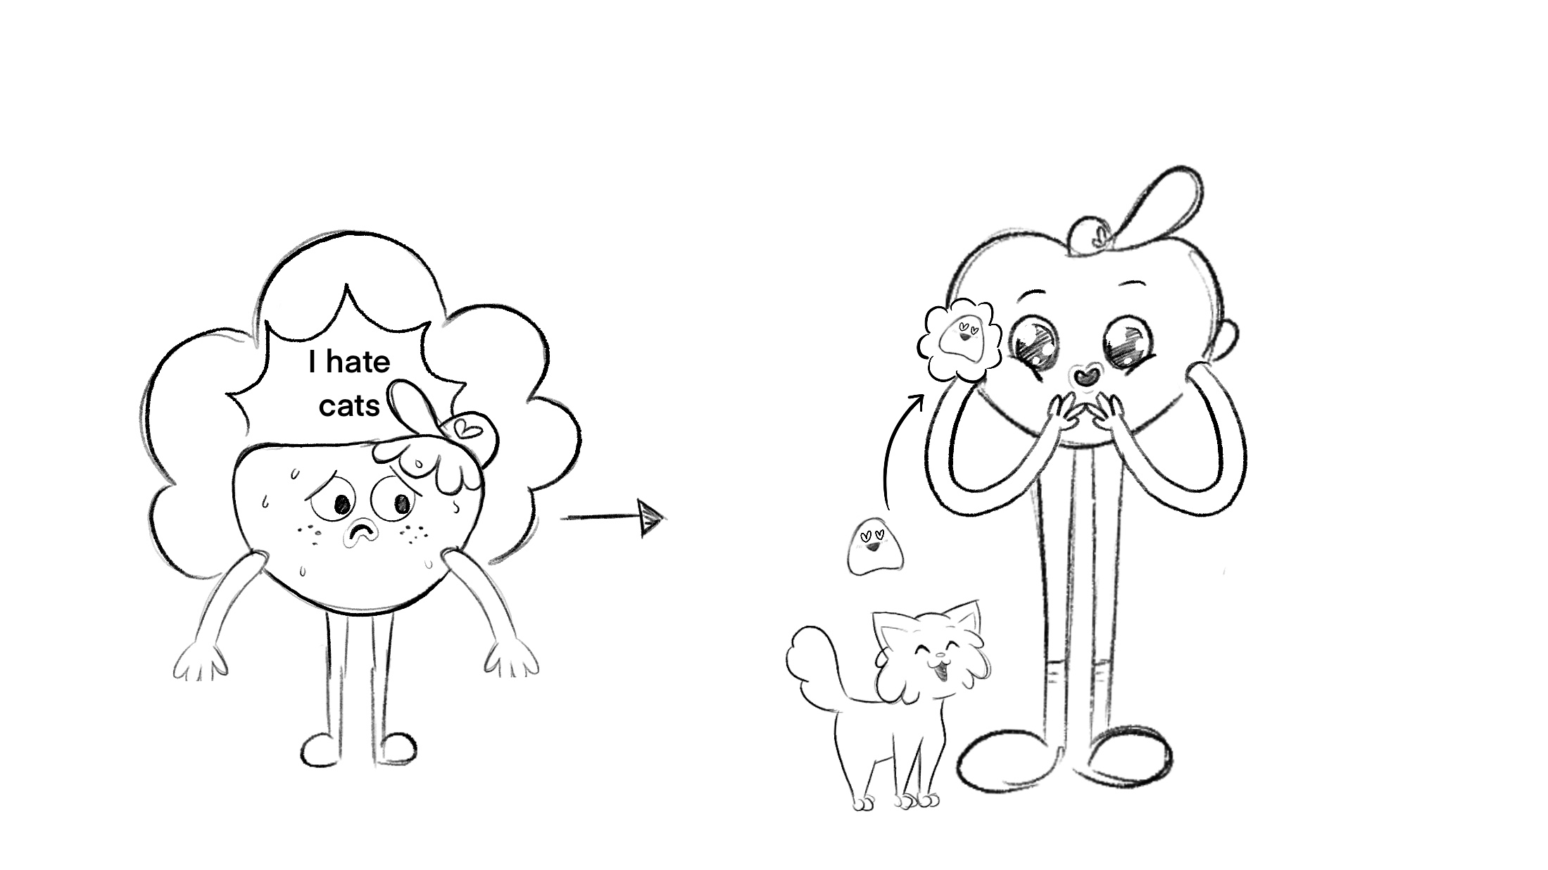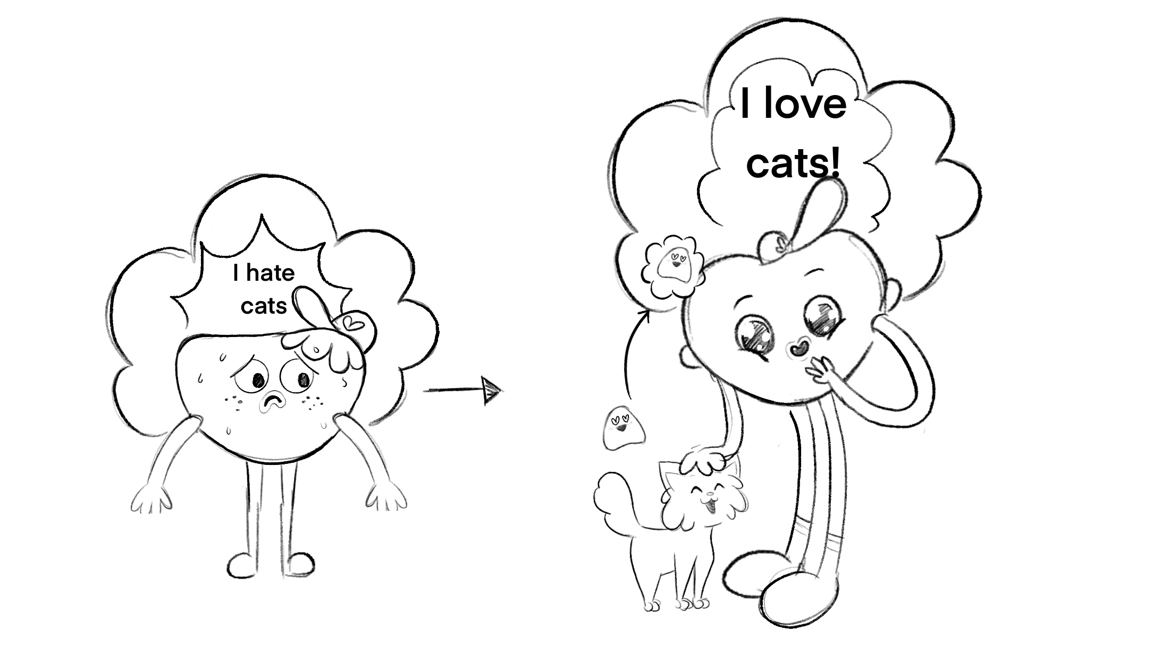  Cat looks innocent and oblivious while SC3 and SC4 look confused at the different emojis coming from the cat.  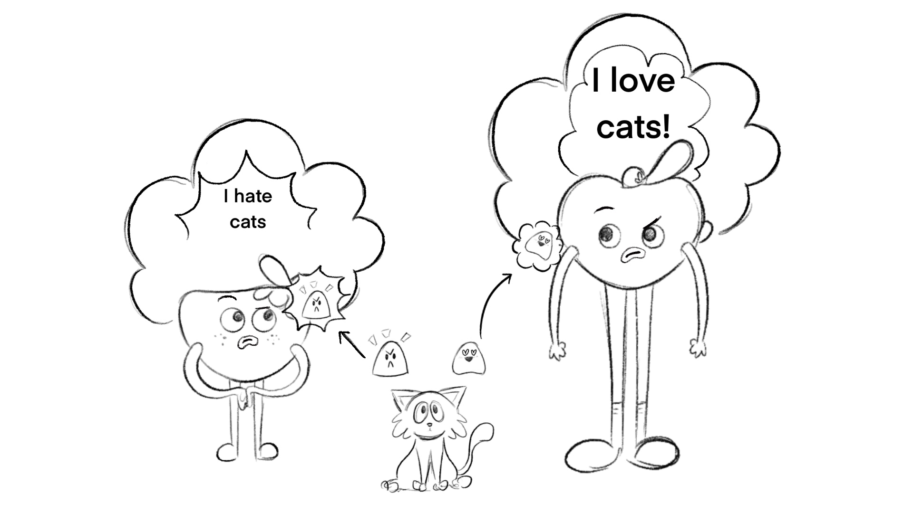
8b | This is because our feelings are actually connected to our thoughts. These two people have different thoughts and therefore different feelings about the same situation. | Emojis stop coming from the cat, arrows are drawn from their respective thought clouds to create a single emoji that covers character and turns into their face.  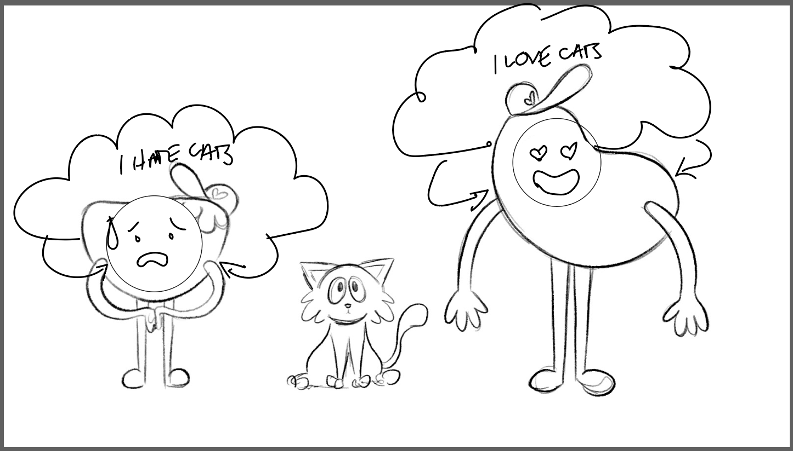
 | In fact, have you ever noticed that you yourself can also have very different thoughts and feelings about the exact same situation? Think about it. Your friend invites you to a party. You think it's going to be fun and you feel excited. | Quick pan down to reveal MC MID CU looking confused. They then “knock” on the camera.  Cut to back view of MC standing in front of a door and as it slowly opens to a blurry “party” (mainly suggested with sound FX) Cut to front view, MC looks happy and excited  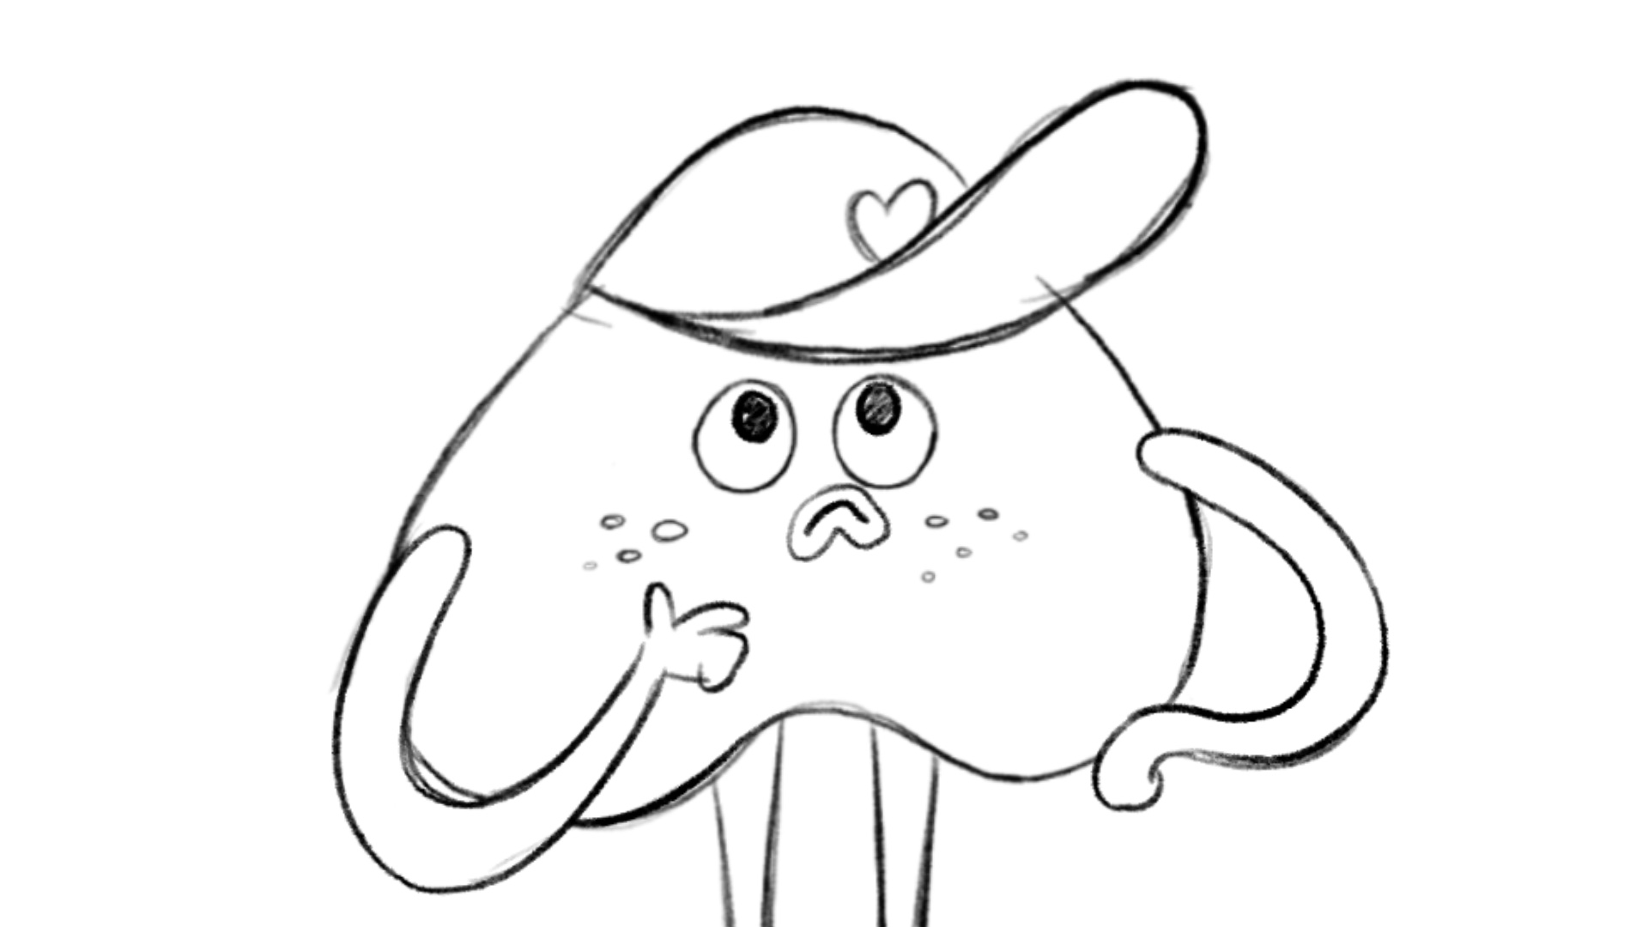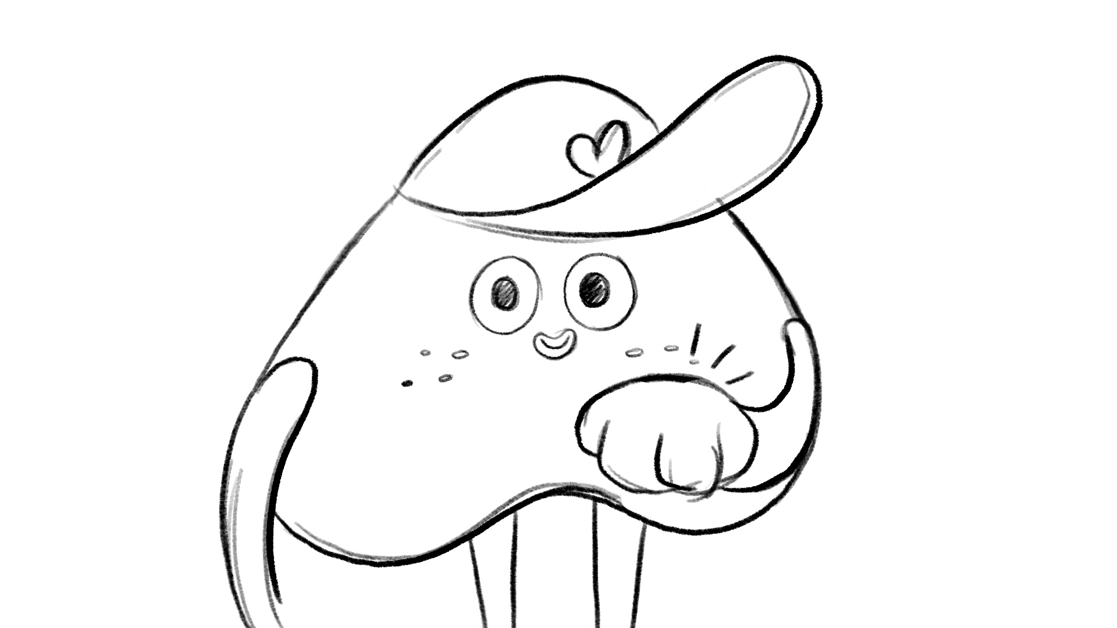  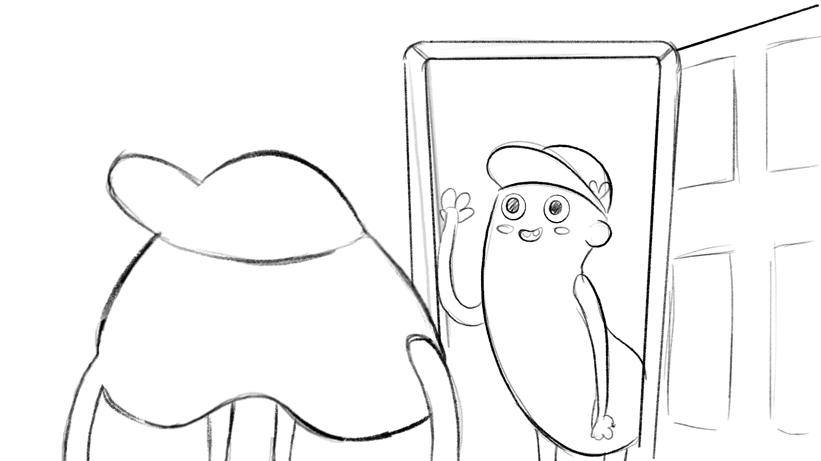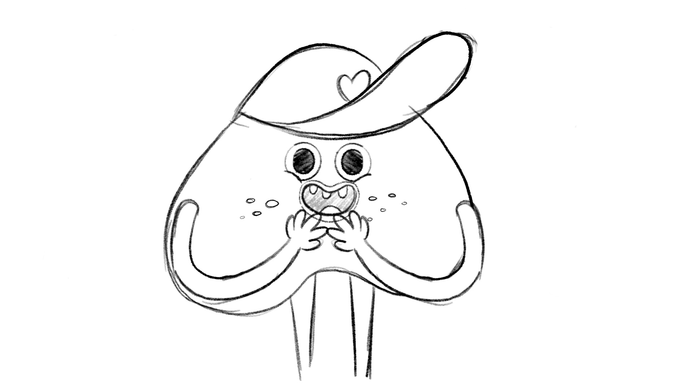
 | The next day, you wonder if you’ll know anyone at the party and you feel nervous and shy. | Quick pan down to same scene with door closed and starting to open. Cut to CLOSE UP front view of MC who screams in fear and runs away leaving blank screen..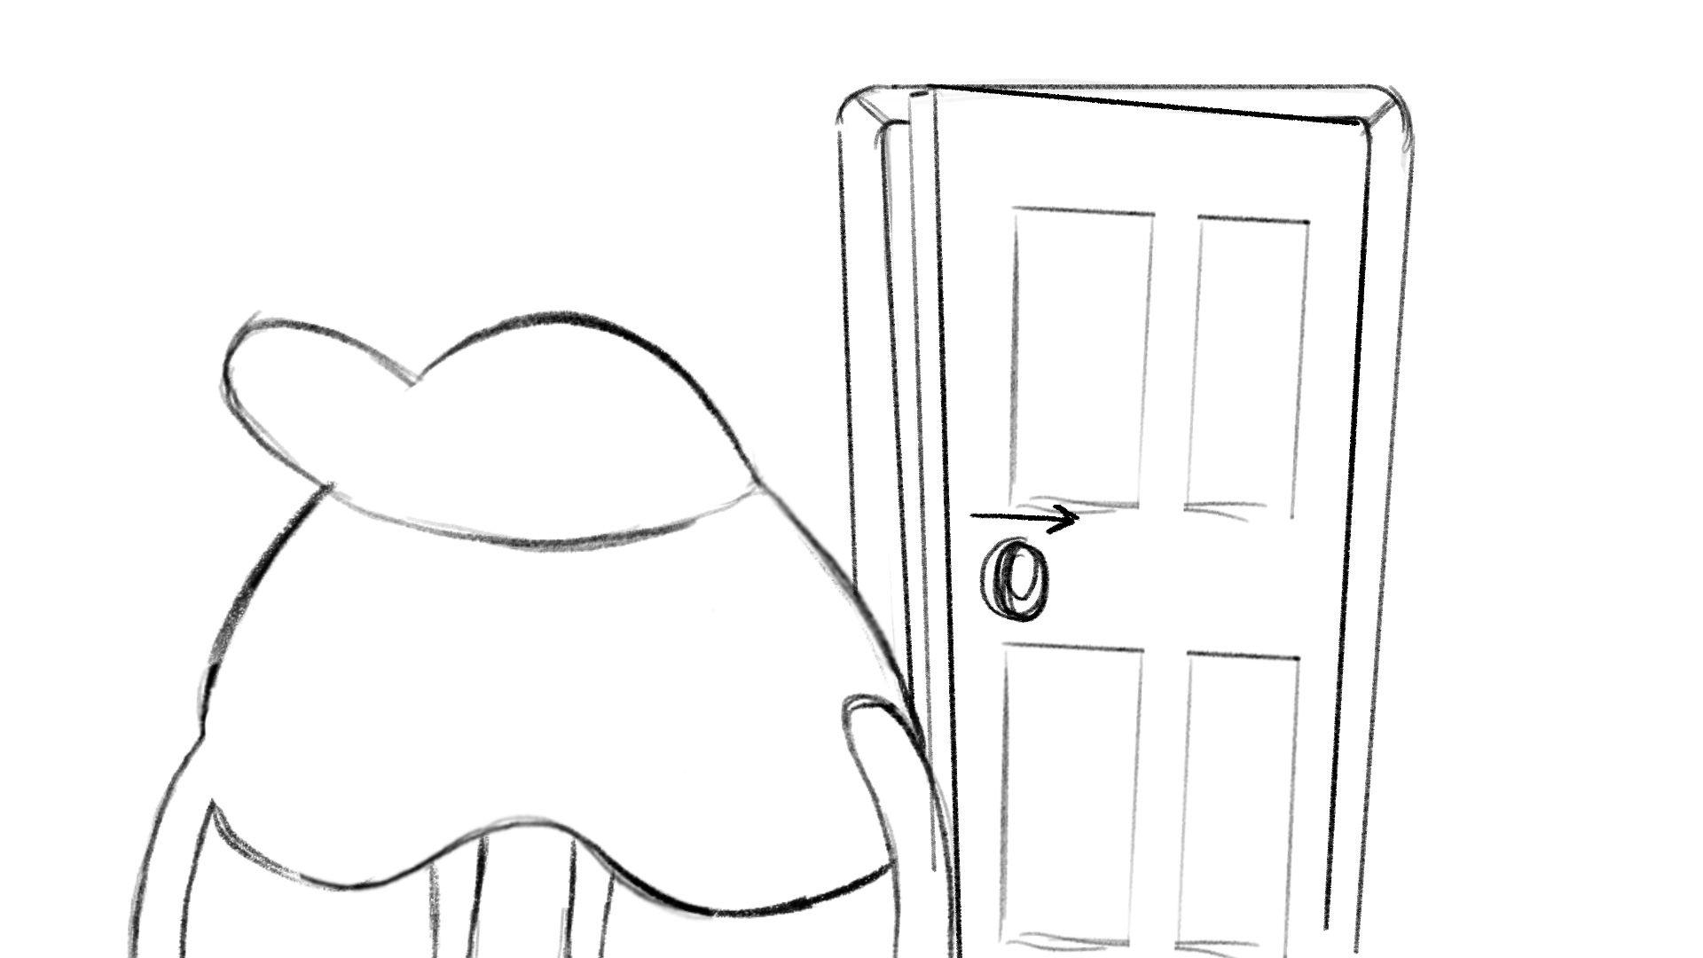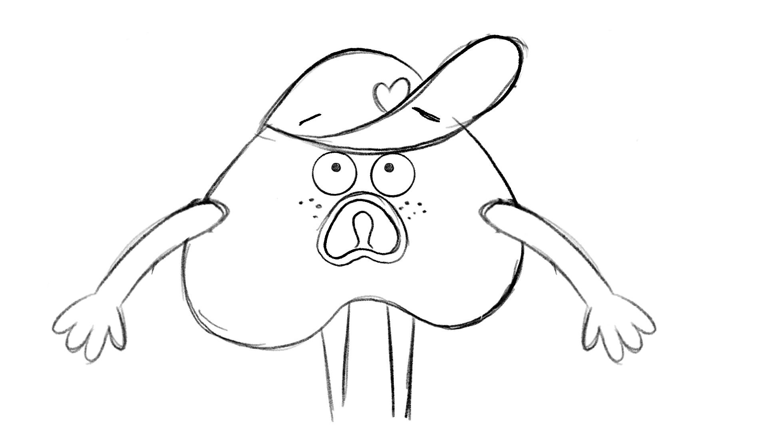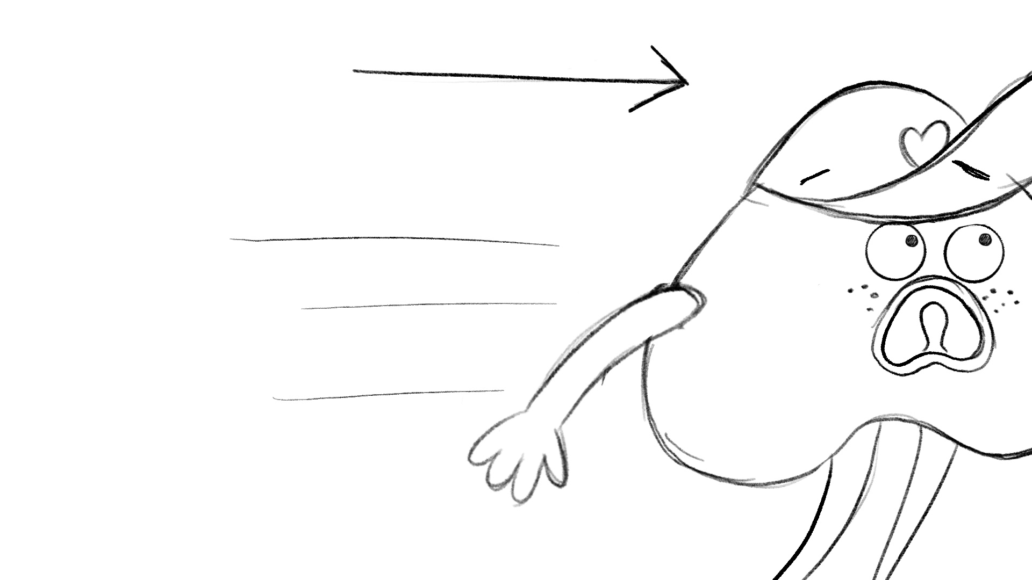
 | This programme is an instruction manual that explains how our psychological system works and why we think, feel and behave the way we do. ‘Psychological system’ is just a fancy way of saying ‘how the mind works’. | Introduce the psychological system image, a revamp of the below, a minority report/instruction manual style overlay titled iHeart Instruction Manual. Wide shot on MC with SC5 in foreground who holds up the overlay. He takes it away and the system stays there  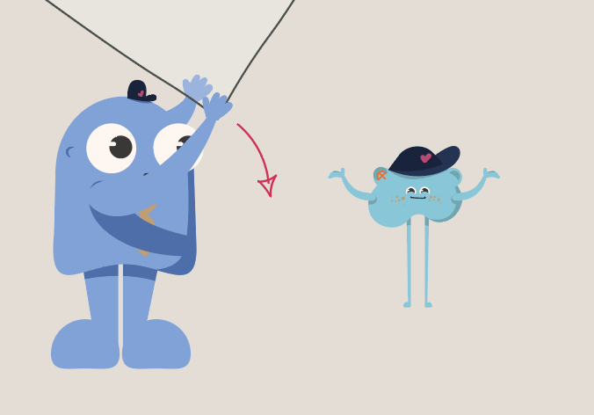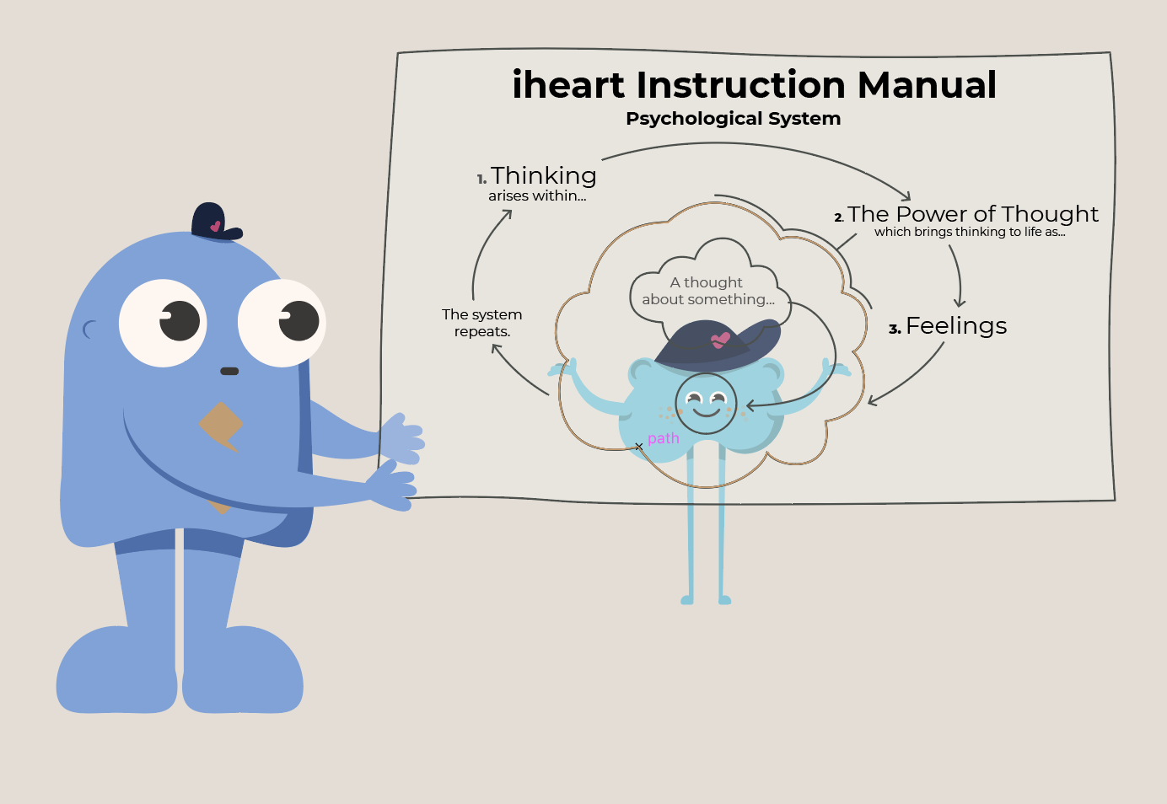transition to “iHeart” title by zoom into corner of overlay.
 | In case you’re wondering, IHeart stands for Innate Health Education and Resilience Training. Innate means something that's built in, that you’re born with. We are all born with well-being. | Cut to “iHeart; Innate Health Education and Resilience Training.” to appear animate it on while it's being said. The word “well-being”is large on screen. They become encased in a circle and then form into the iHeart emblem which then grows into Baby MC and the darkness around them fades.  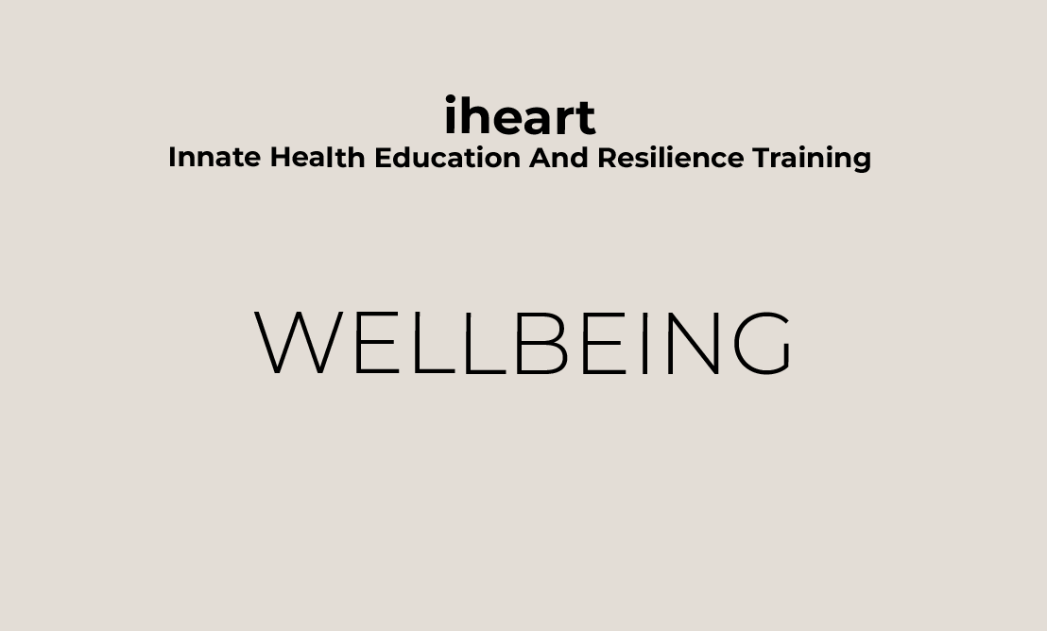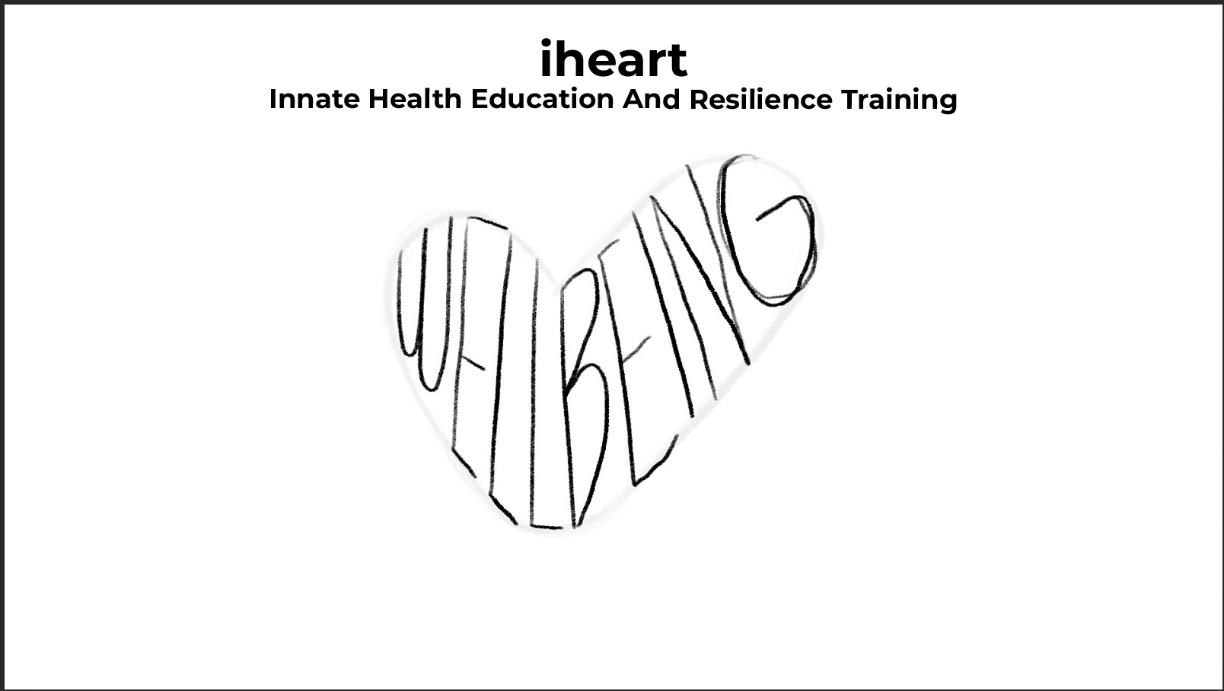  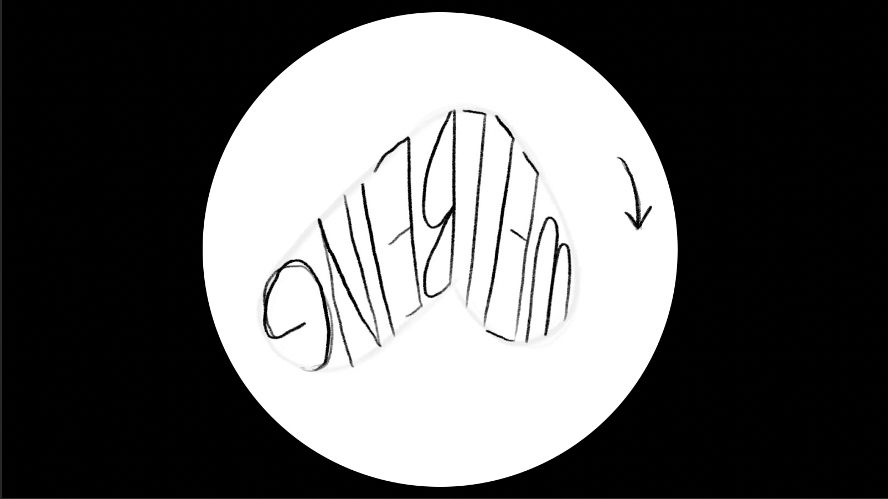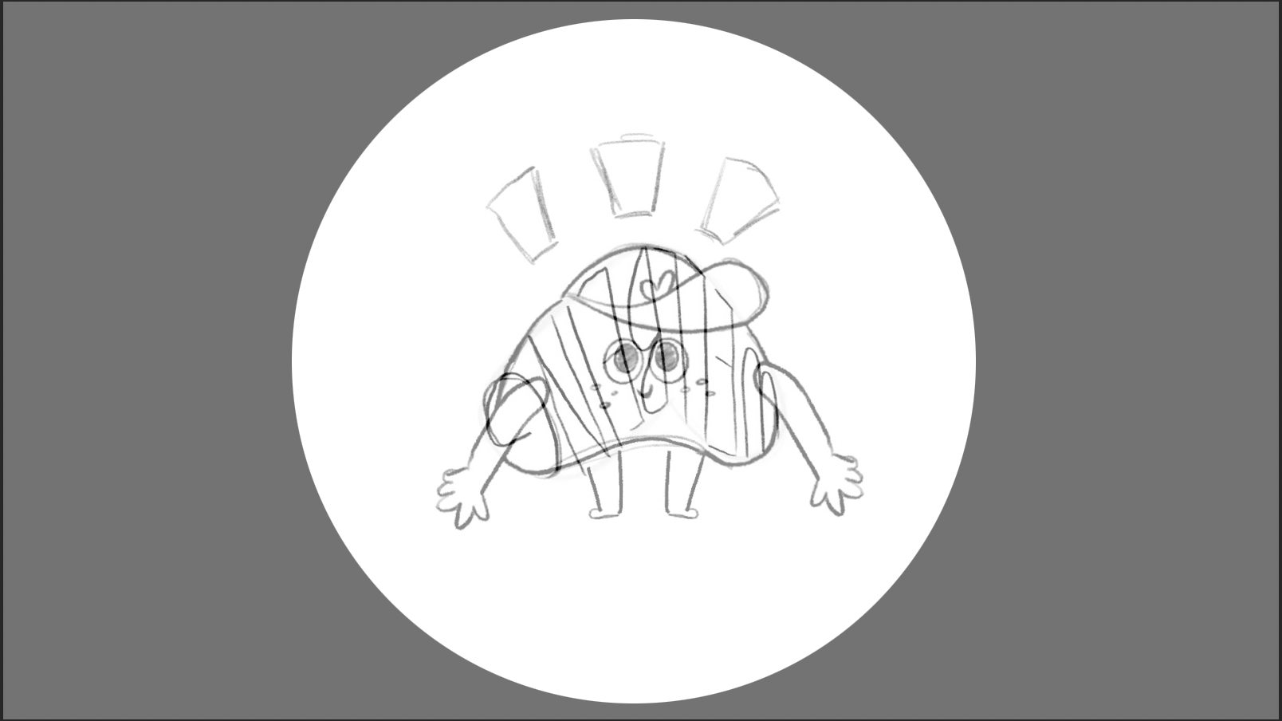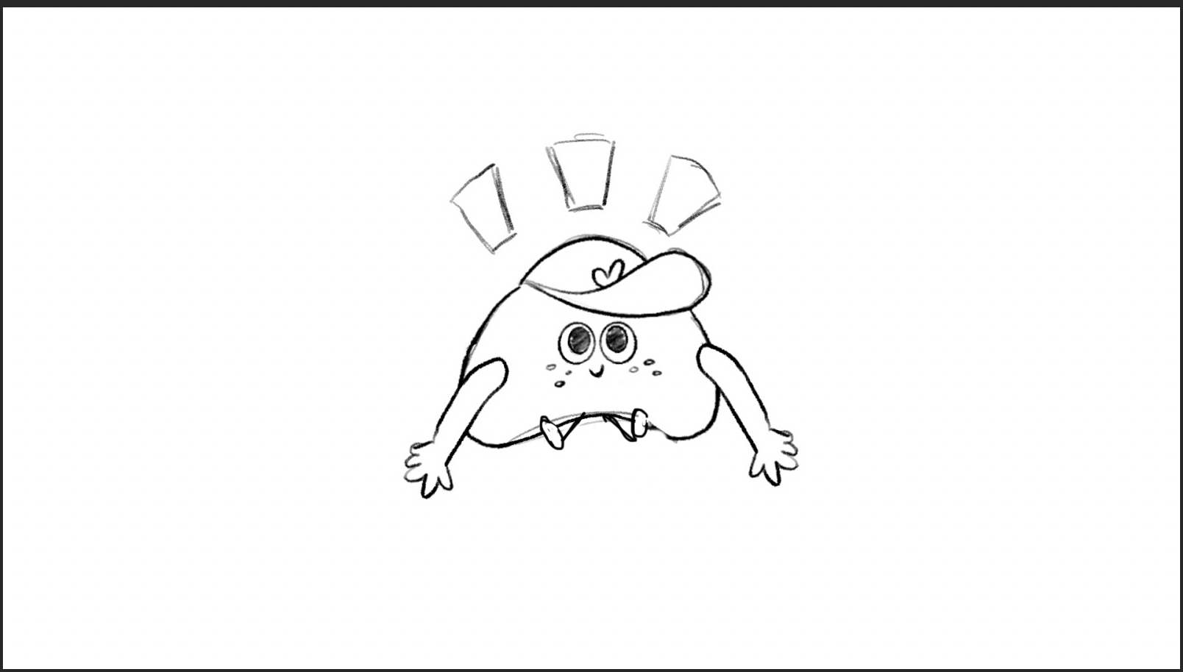  Glow lines go into body.
12b | And resilience means that you’re always ok, even when you think that you’re not. Resilience is a part of well-being and is built into our psychological system, It is our natural state and is always a part of us. It can never be damaged, lost or broken. | Baby MC tries to stand, falls over and is upset.  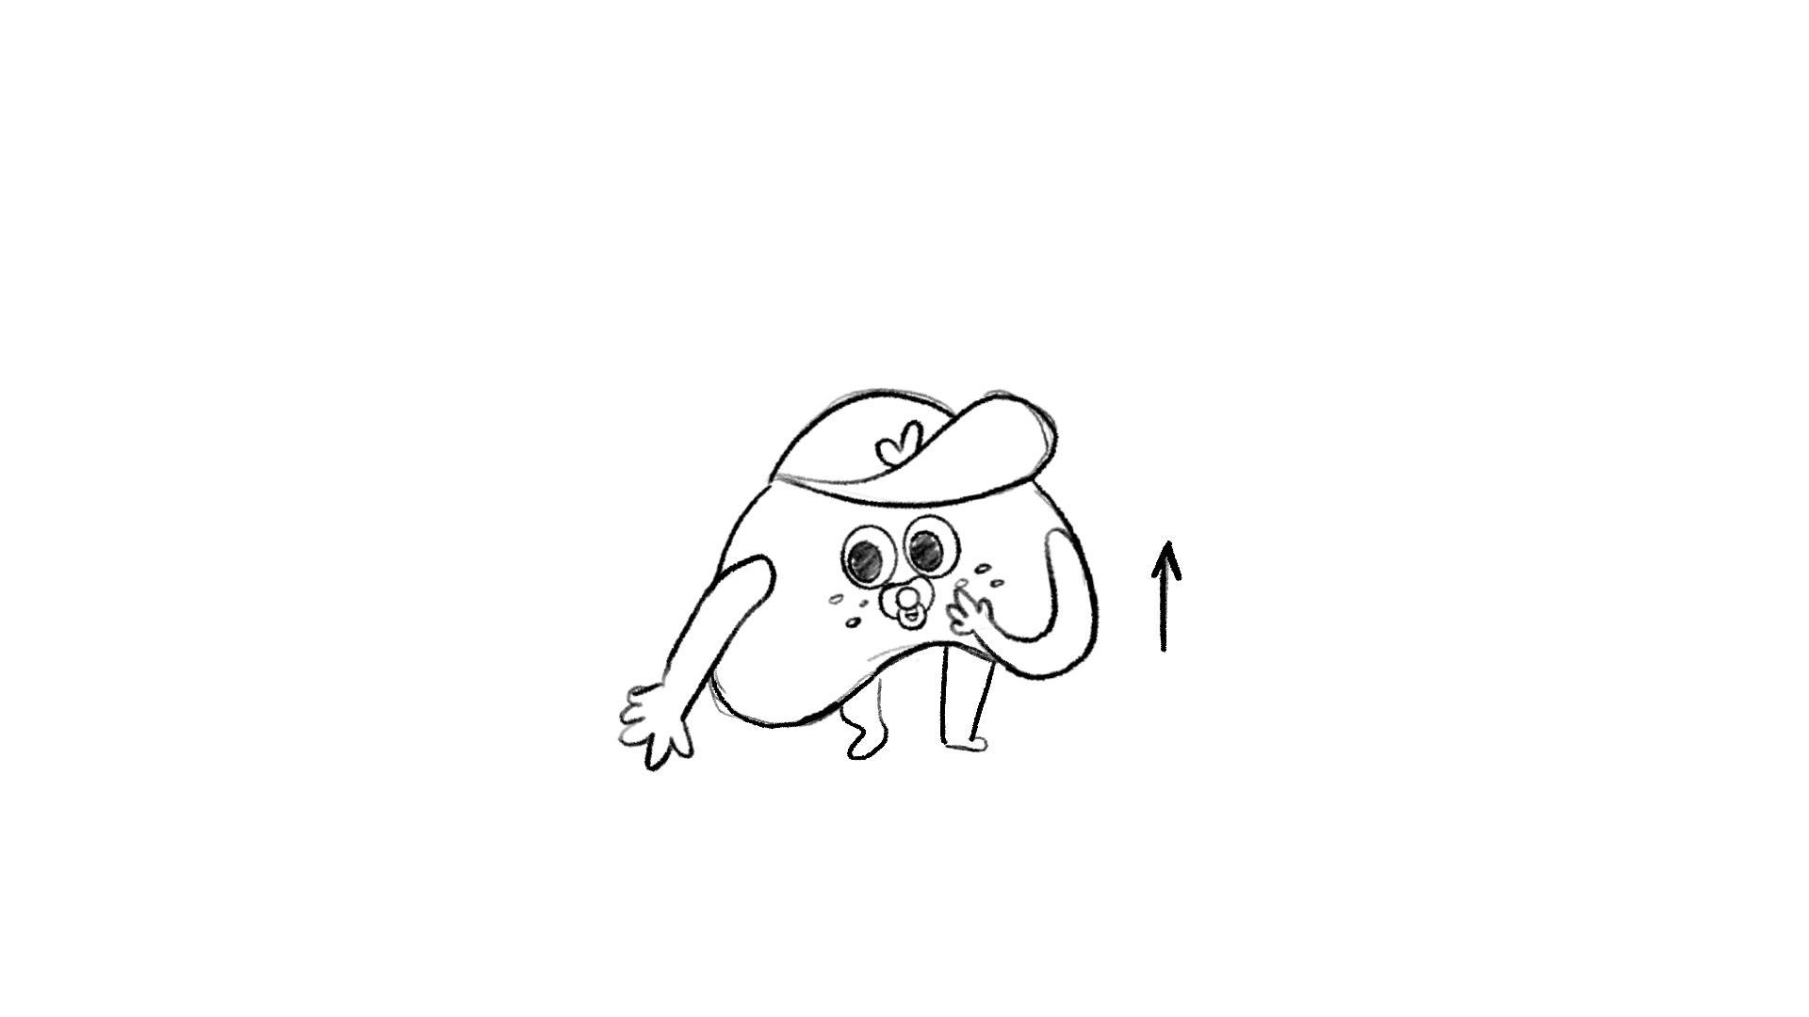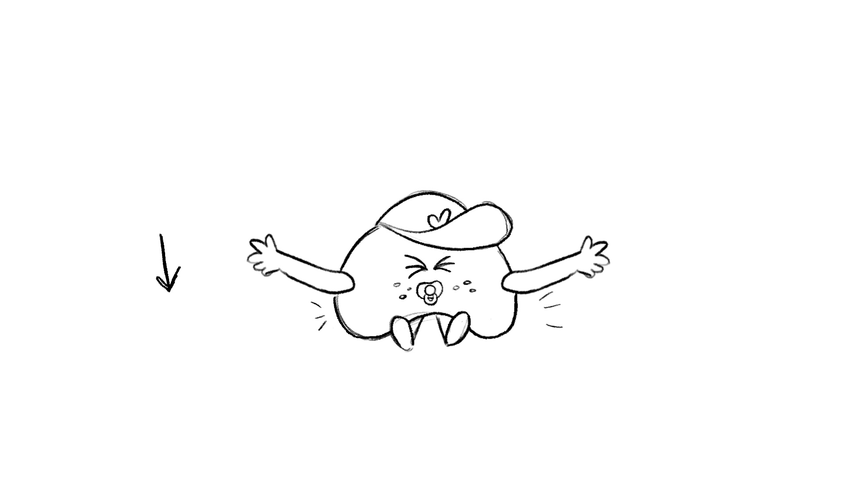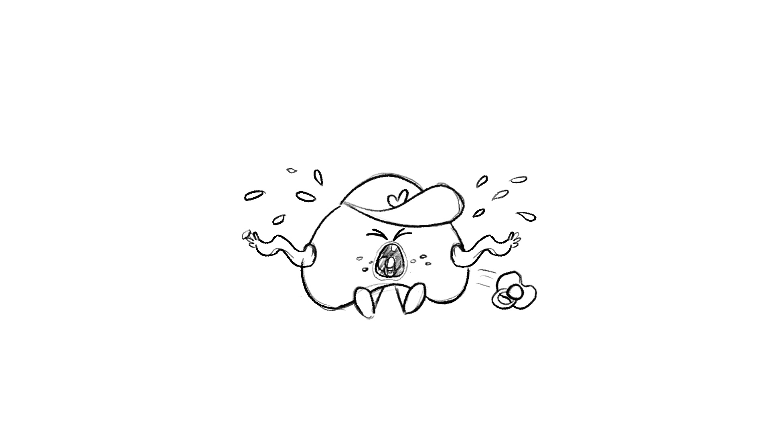  Minority report overlay shows psychological system including the word resilience forming the shape of the character.  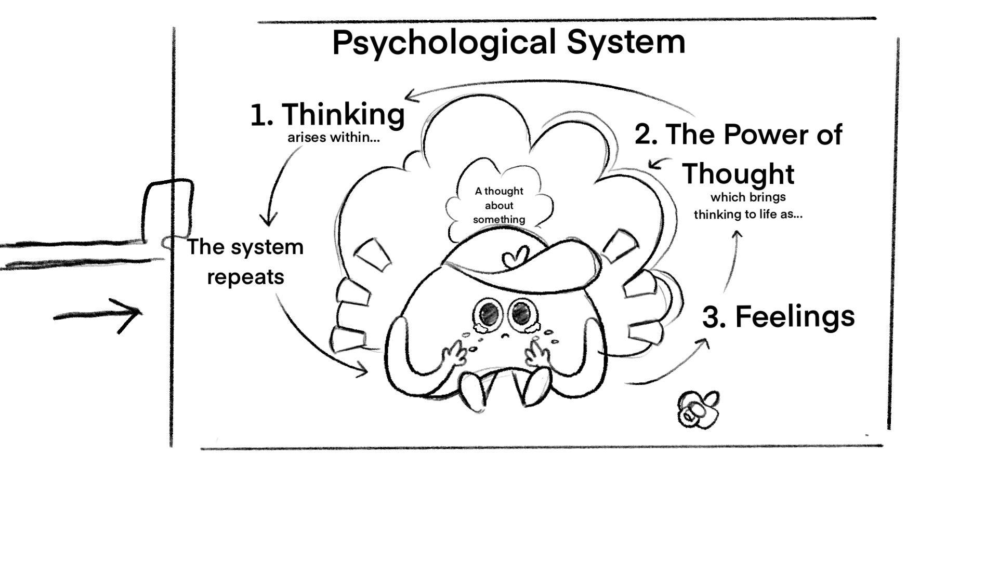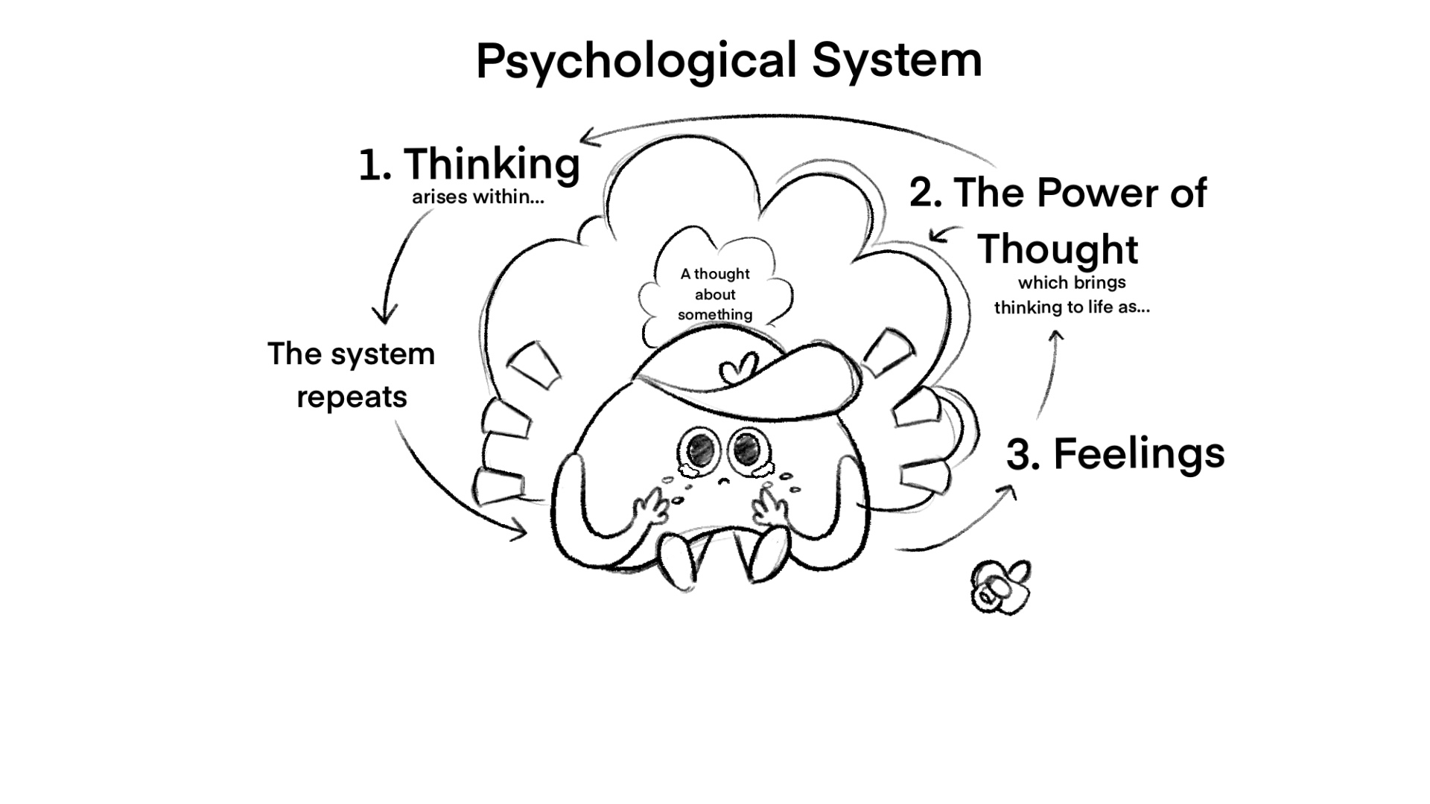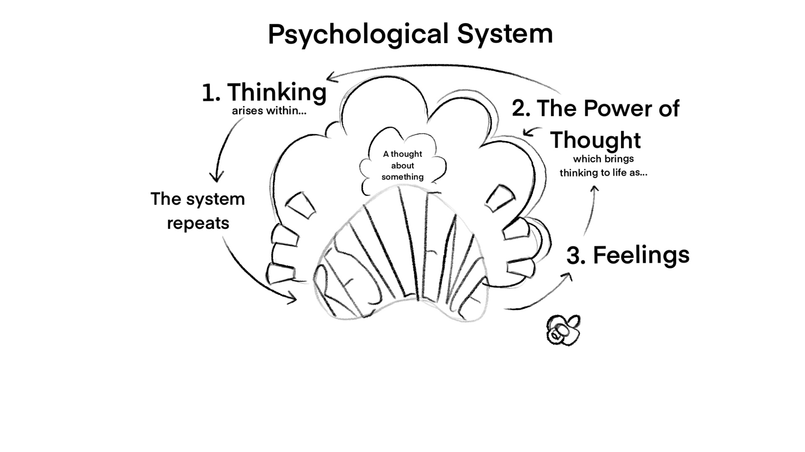
 | But if it’s innate, why don’t we always feel our well-being? We’ll explore why it gets covered up. And we’ll show you that you have an inbuilt compass to help you uncover it again. | Cut to MC at a crossroads, glow lines around him. Starts to walk down one road and the glow lines start to fade as they start to look troubled. His tummy expands to contain a compass that is point away from North, MC does some navigating to make compass point North and they look amazed.  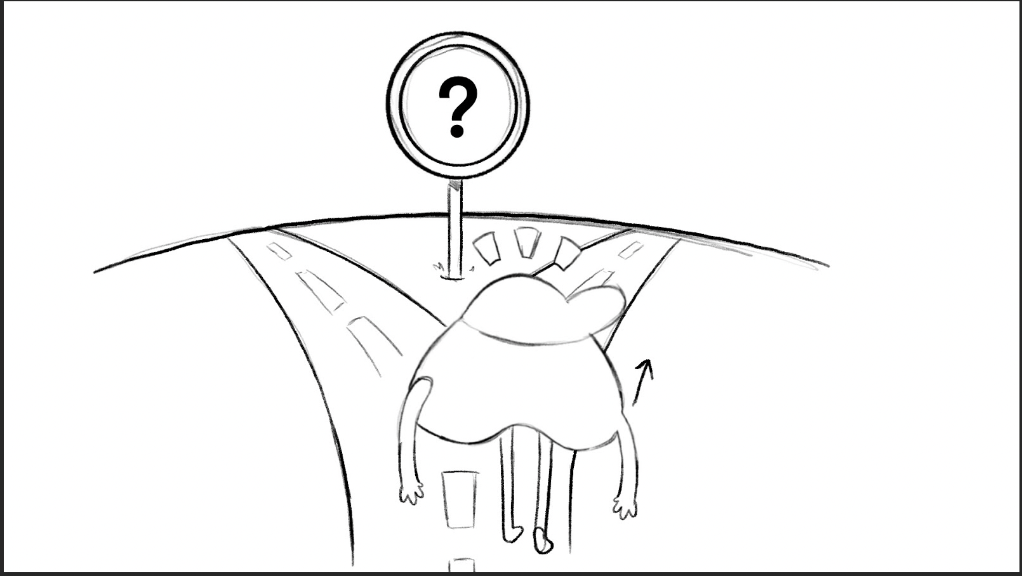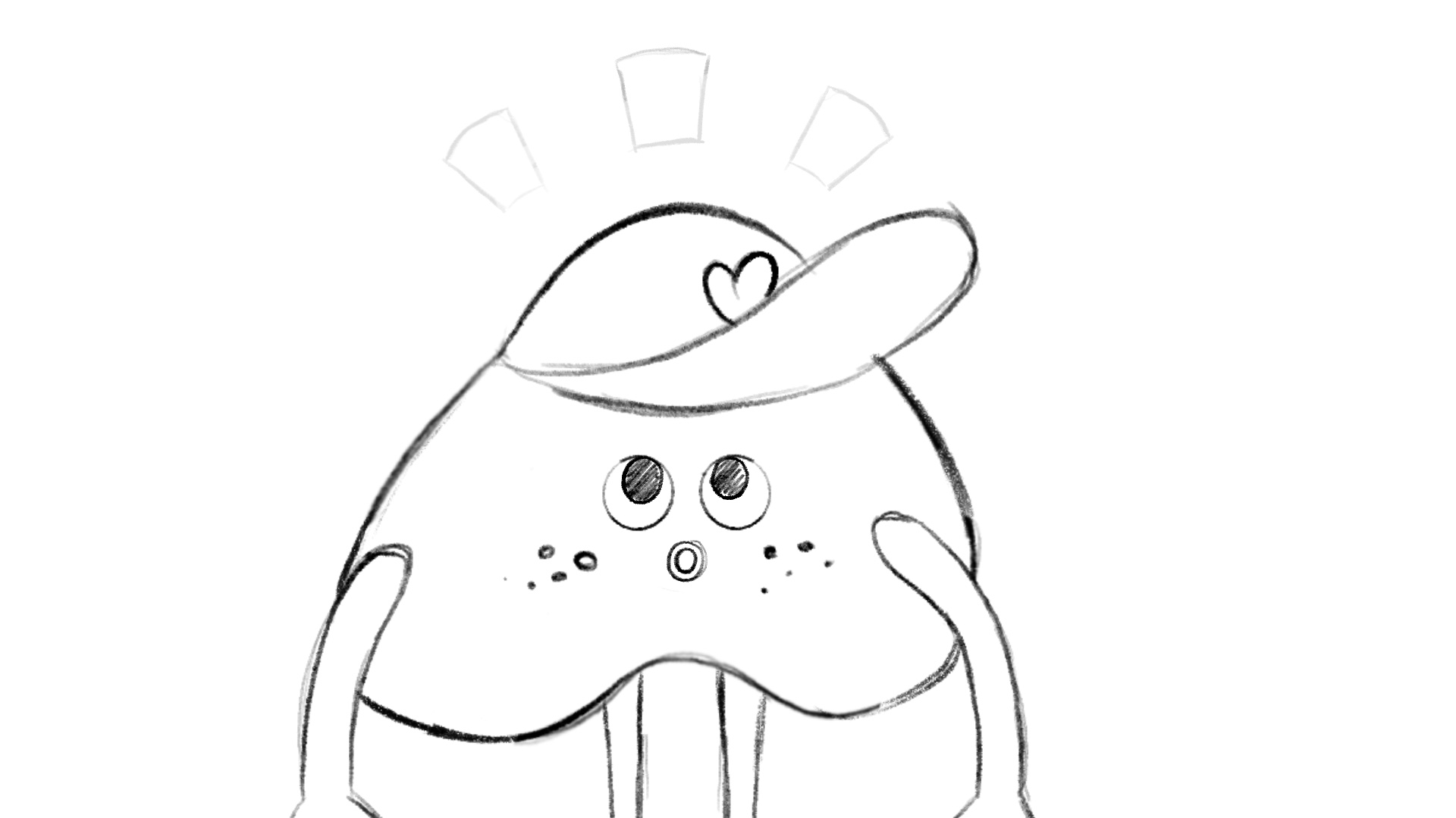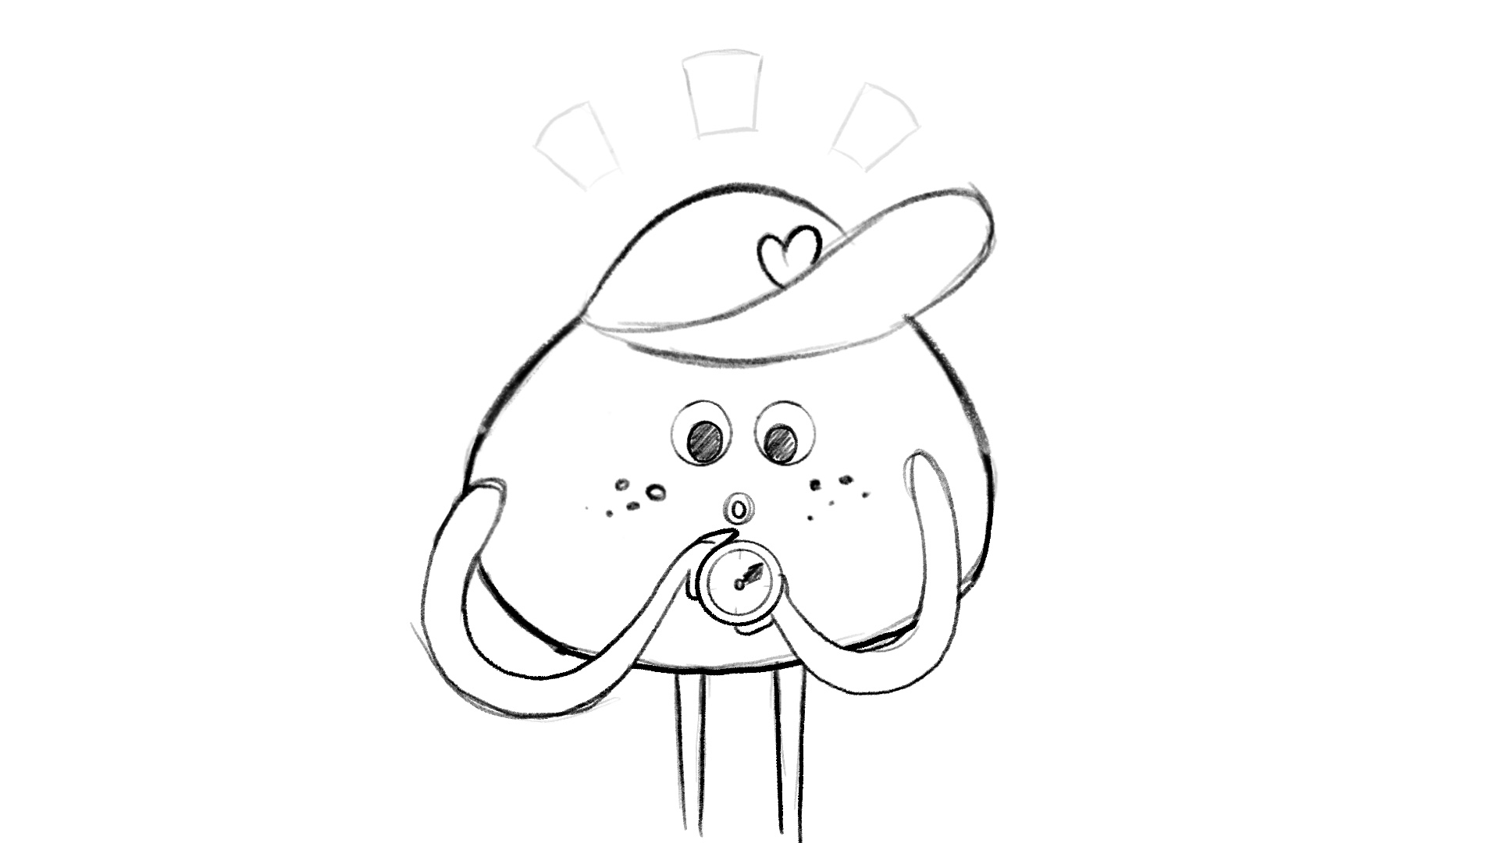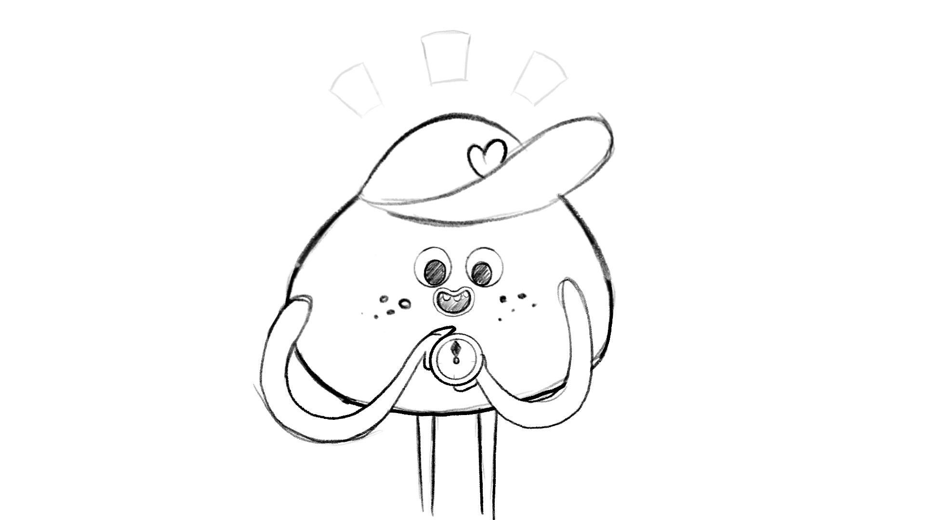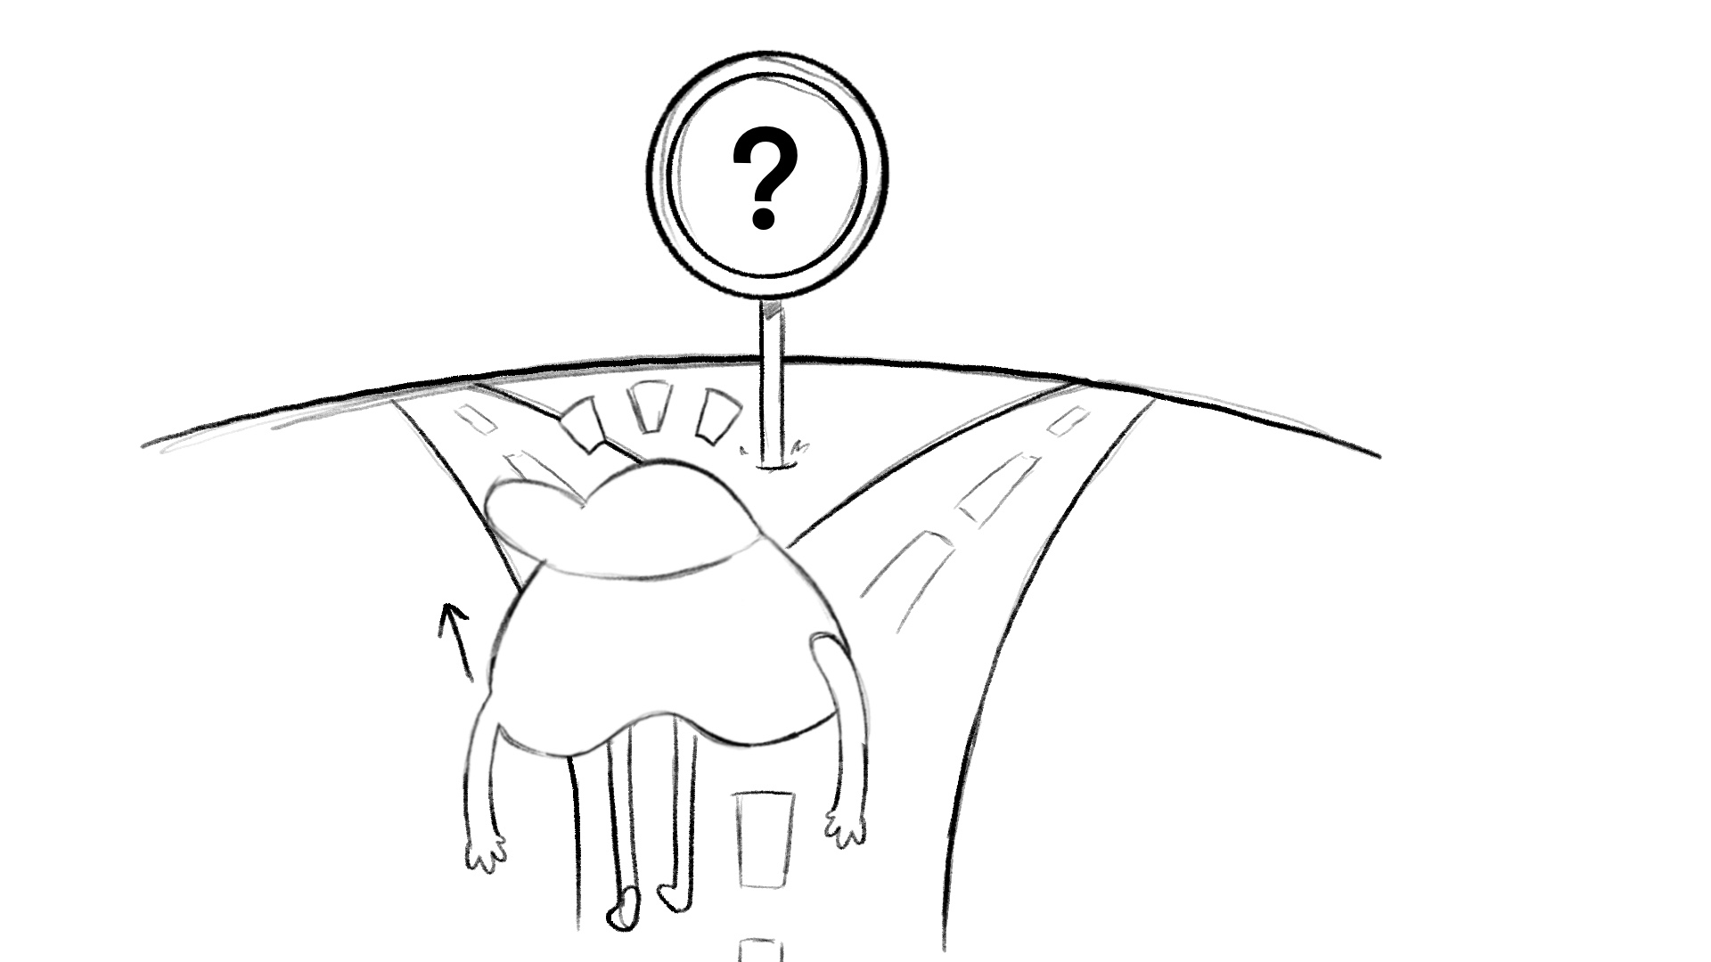  Glow lines fade back in last shot.
 | You might be wondering if this programme is for you. The answer is yes! No matter who you are or where you live, whether life is going your way or there are things that you’re struggling with, this programme will help you achieve your very best potential in ALL areas of your life. | The other characters join the MC all with varying emotions written in their thought clouds and the iHeart emblems pops up on each of them as a tick. when we say “going your way” can character have hands in air and when we say “or not” can a character have his head and hands down as in a slump to illustatre VO little more  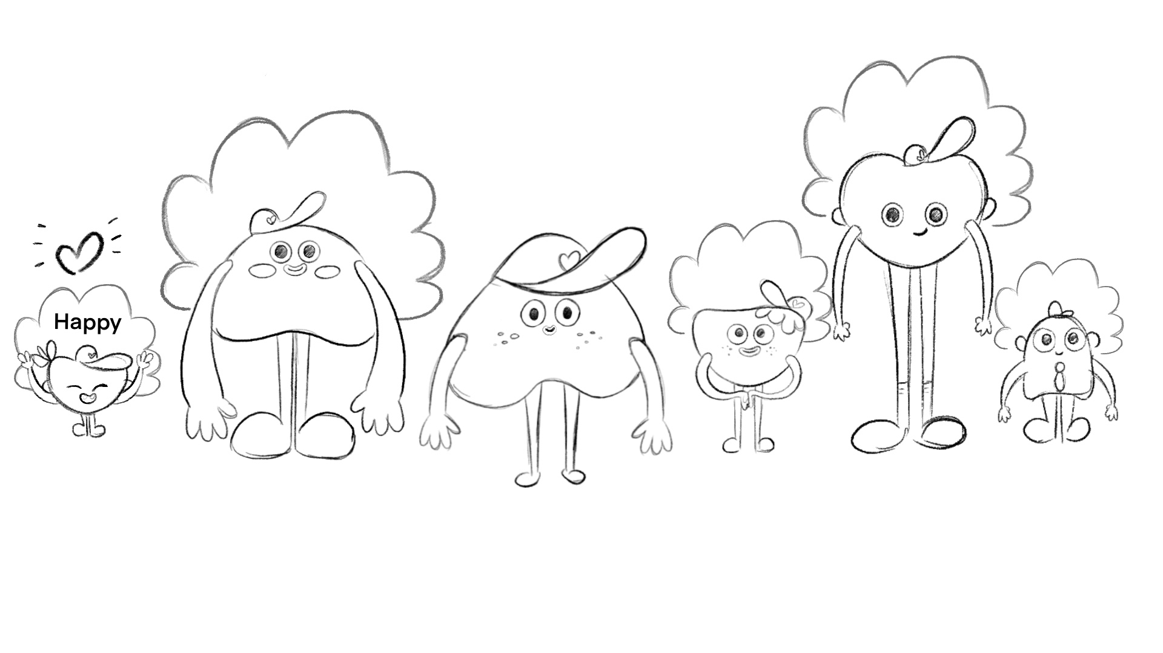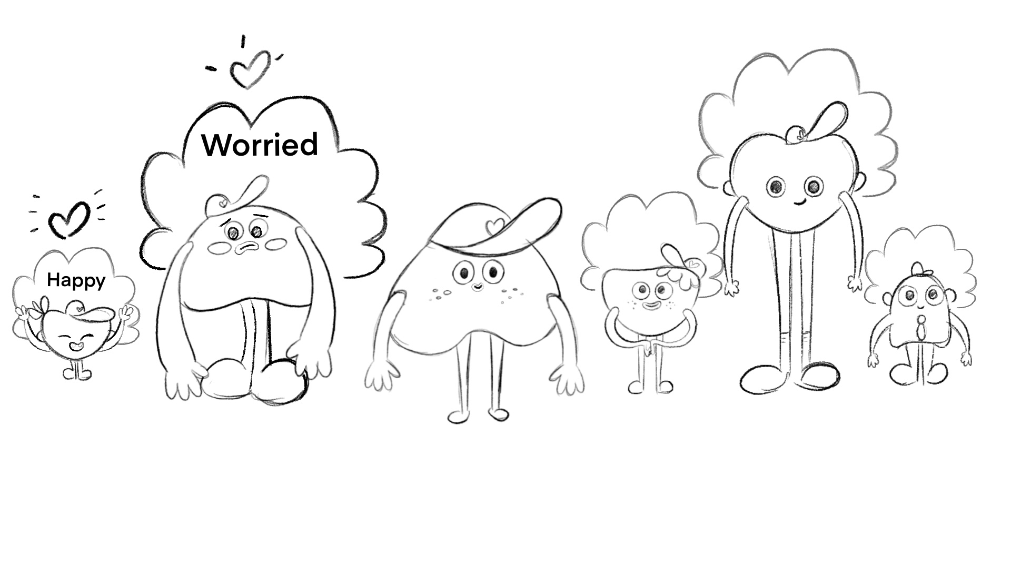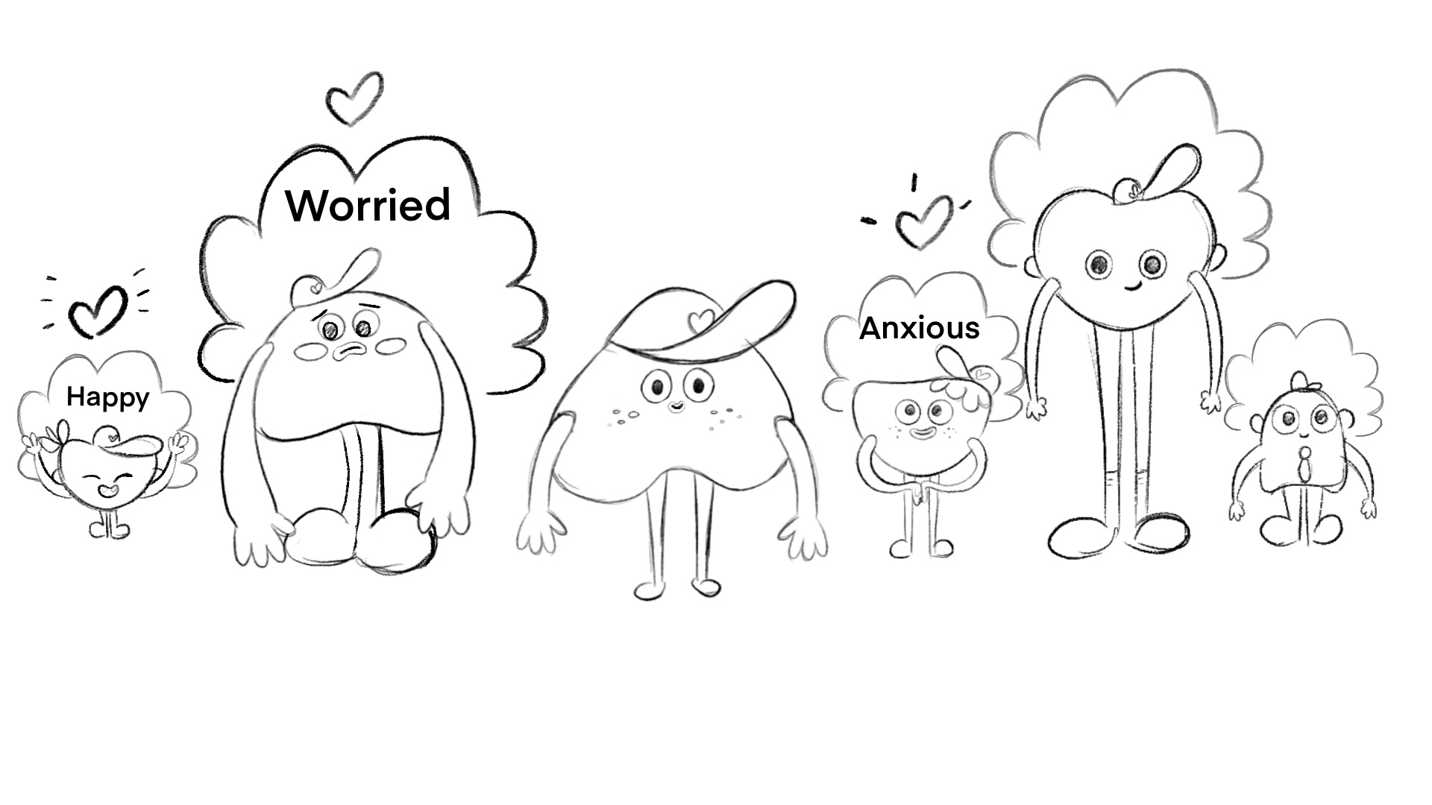
 | During the programme, we’ll look at topics that are on a lot of young people’s minds, like:  How do I stop overthinking  I’m worried about the future  I can’t get over hurt.  Why do I get anxious, worried and stressed?  Can we disagree and still be friends?  How to connect better with others  Help, I’m being bullied!  How do I break bad habits  I’m a slave to social media!  Feeling good about myself.  I feel judged.  How can I feel motivated and enjoy learning? | Designed still frame of MC referring to a poster stating all topics/road map showing journey..  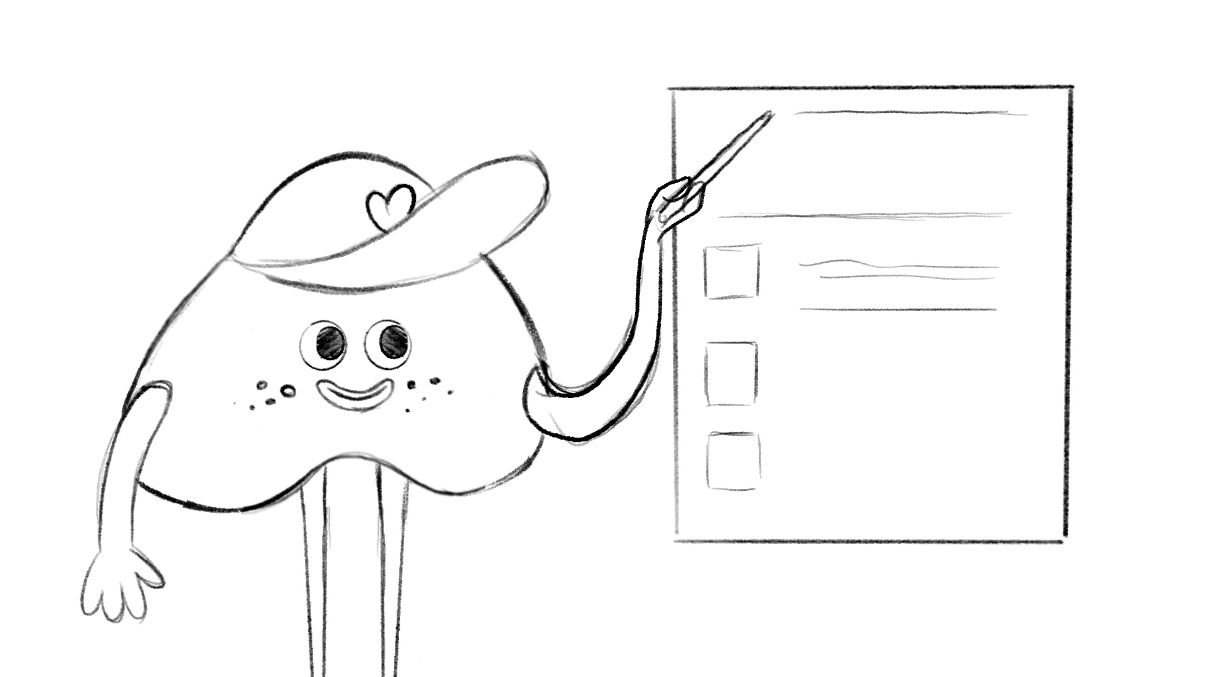
 | (Show map of the world) IHEART is being taught in many countries around the world.  We caught up with some students who’ve already completed the IHEART programme and here’s what they had to say …. | Designed still image of world map with iHeart logos where it’s being taught  New Zealand , South Africa , Australia , all over UK , Ireland  Scotland, US ( all over ( Canada , Scandinavia ie Sweden and Norway ) , israel  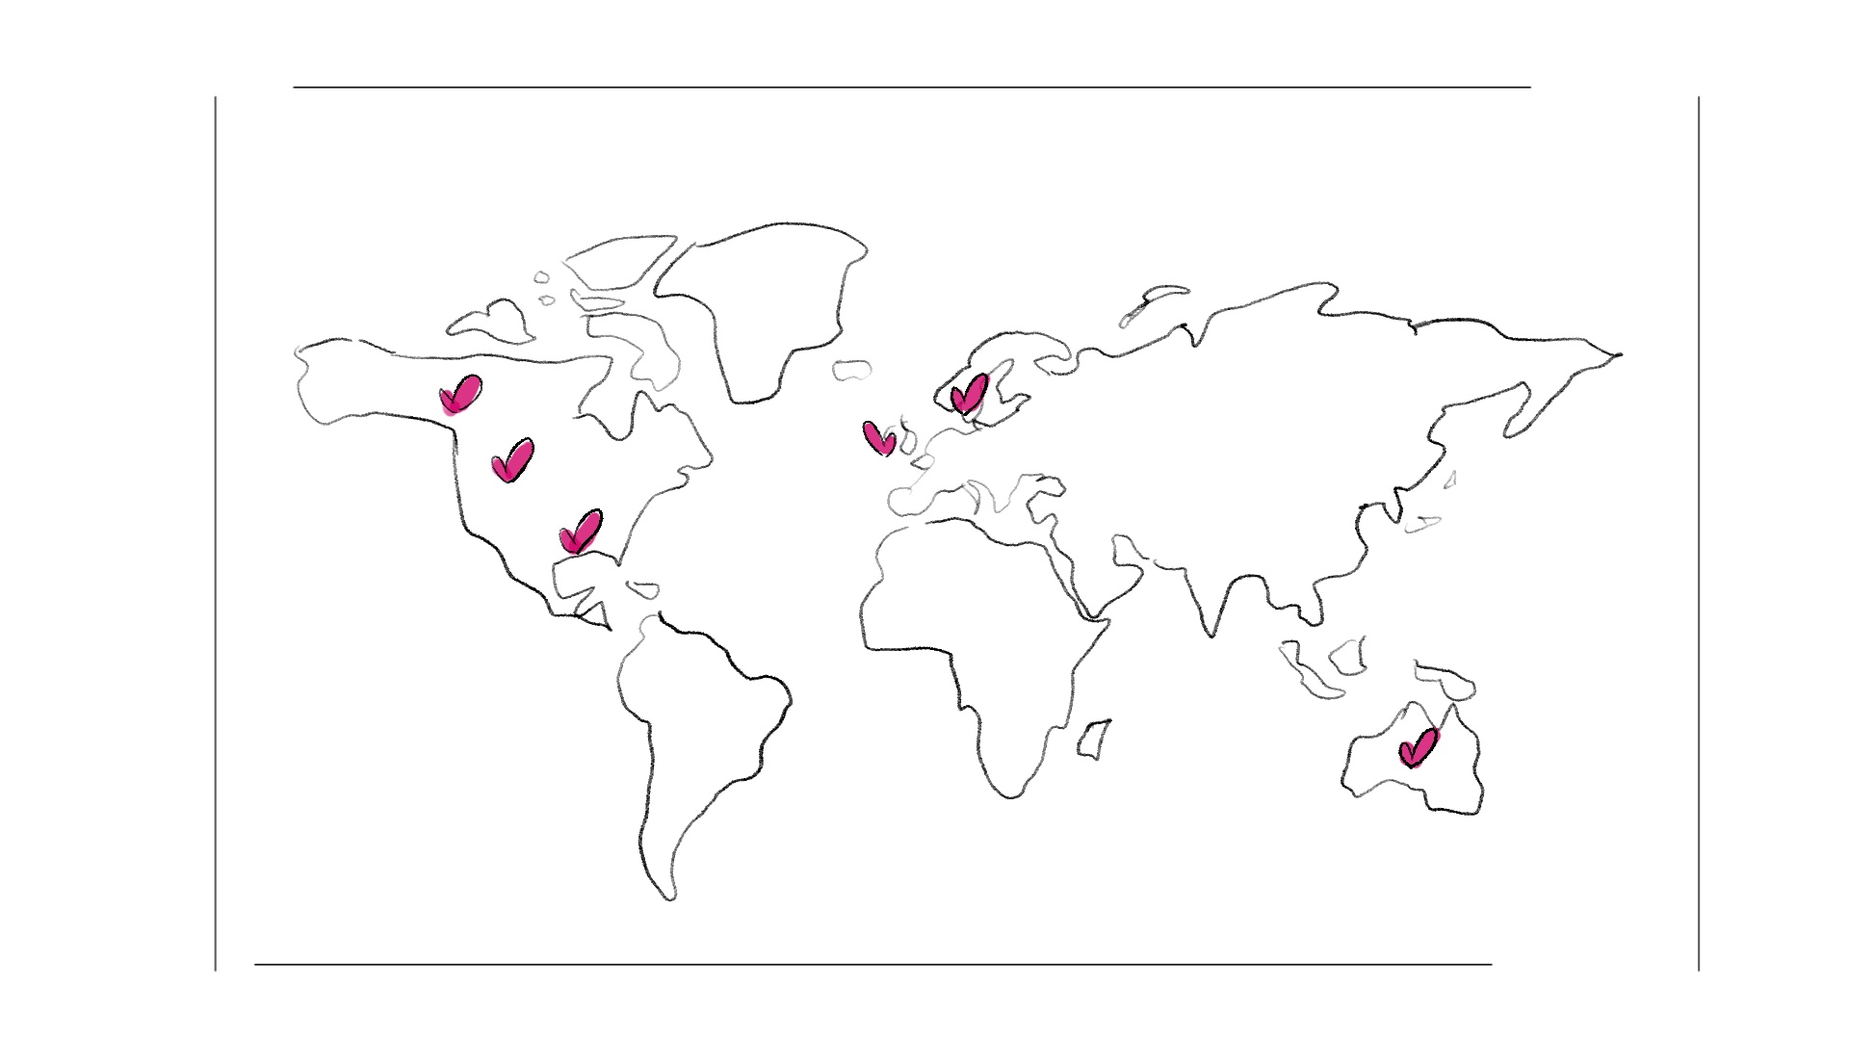
 | (fill in videos here of six different age/demographic kids each speaking for 20 secs at most ) | Edit of videos
 | There’s so much to explore. | Still of iHeart characters  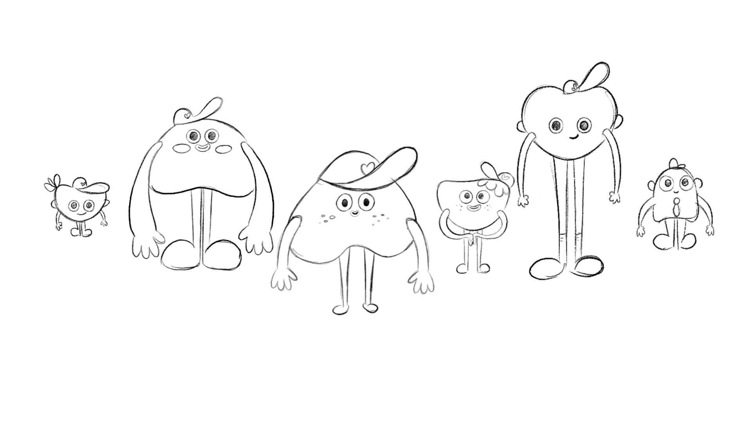
 | Let’s take a look at what we’ve learnt so far:  - The iheart programme explains how our minds work - why we think, feel and behave the way we do.  - Well-being is built into our psychological system, so it’s a part of everyone!  - We don’t always feel our well-being, but there’s no need to worry ...it’s always there. | Designed still frame of MC referring to a poster stating all learning objectives.